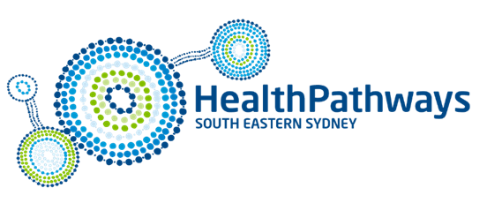
Annual report FY23

SES HealthPathways (SESHP) was launched in 2018, it is a partnership between South Eastern Sydney Local Health District (SESLHD), Central and Eastern Sydney Primary Health Network (CESPHN) and St Vincent’s Hospital Network Sydney (SVHNS). The program also works closely with Sydney Children’s Hospital Network (SCHN). It is an online tool to support GPs during patient consults. It also has benefits for the hospital systems and patients.
SESHP’s mission is to deliver high quality pathways in areas of local need. These pathways are always developed in collaboration with local GPs, health professionals and Subject Matter Experts (SMEs) to help our community and health care consumers receive integrated care. The program’s three strategic priorities are:
- Pathway development
- Engagement with clinicians
- Data and technology use
There were approximately 550 live pathways by the end of FY23. Existing pathways are regularly reviewed to ensure the content remains up to date.
Access SES HealthPathways
Access is available to health care workers only. Please contact SESLHD-HealthPathways@health.nsw.gov.au for the generic log in details.
SESLHD and SCHN staff can access SES HealthPathways through the intranet.

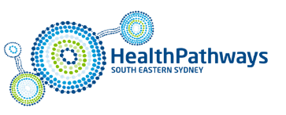
FY23 pathway use:
- 3,317 users
- 89,453 page views
- 30,376 sessions

In FY23 SESHP celebrated:
- Reaching a milestone of 500 pathways
- The launch of our strategic plan
- Wide stakeholder input and agreement on priority pathways

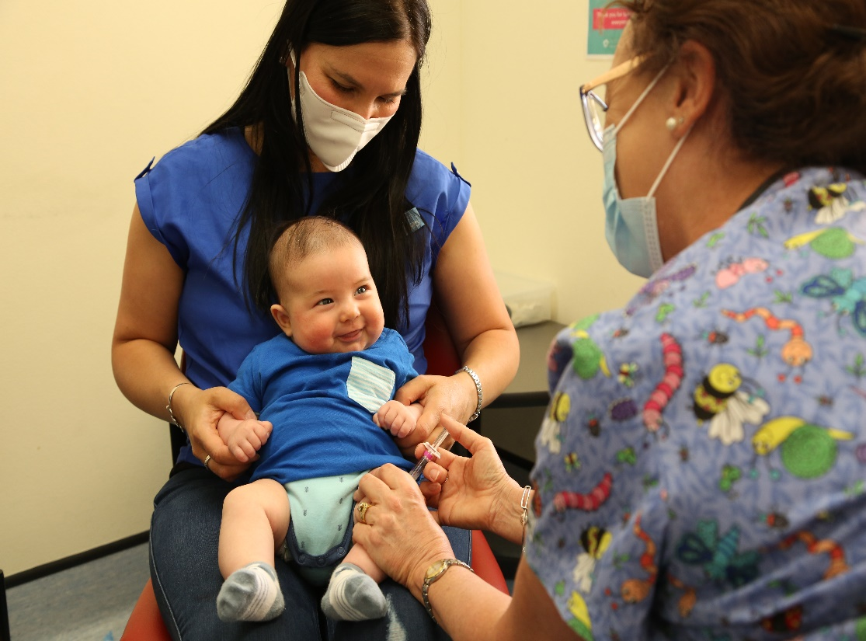

Top 10 pathways viewed in FY23:
1 | COVID-19 Management
2 | Antenatal – First Consult
3 | COVID-19 Requests
4 | Antenatal – Routine
5 | Hypertension
6 | Post-COVID-19 Conditions
7 | Miscarriage and Ectopic Pregnancy
8 | Hyperlipidaemia
9 | Abnormal Liver Function Tests
10 | Osteoporosis

For further information please contact the SES HealthPathways team
SESLHD-HealthPathways@health.nsw.gov.au

