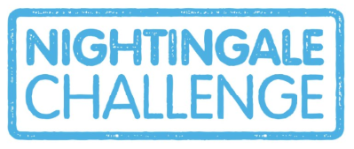

Application Form
Name: | Employee Number:
Facility: | Unit/Ward:
Date of Birth: | Age (At time of application):
Current Role: | Signature:

Line Manager to Complete:
*for more information on the Nightingale Challenge, visit https://www.seslhd.health.nsw.gov.au/nightingale-challenge
I, __________________________ support _______________________ , to accept the Nightingale Challenge.
(Manager’s name) (Employee name)

Signature: ___________________________________________
Date: _______________________________________________
Leadership Development Programs (indicate the program you have chosen to enrol in):
□ Clinical Leadership Program
□ Effective Leadership Program
□ Leading For Improvement Transformation (LIFT)
□ Institute for Improvement in Healthcare Modules (My Health Learning)
□ Emerging Leaders Program (POWH staff only)
□ Cost Centre Management (POWH staff only)
□ Nursing & Midwifery Leadership Teams (Heart of Caring)
□ Clinical Redesign
□ AIM Workshops
□ Future Nursing & Midwifery Unit Manager Program (SGH staff only)
□ Next Step Program Nurse & Midwifery Manager (SGH staff only)
□ Education Program for NUMs & MUMs - ‘NUM School’ (SGH staff only)
□ Take the Lead Two
□ Mental Health Leadership Development Program (Mental Health Services staff only)
□ Facilitation Development Workshops
□ People Management Skills Program

Application Checklist:
- Nightingale Challenge Application Form with signature of support from manager
- Proof of enrolment in a Leadership Development Program from the list above
SEND TO: SESLHD-Leadership@health.nsw.gov.au

