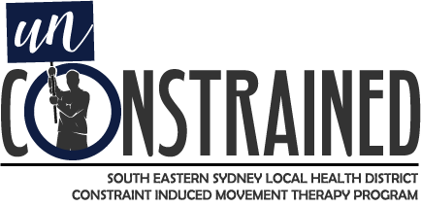
What is it? Constraint induced movement therapy (CIMT) is an evidence-based treatment method for people who have arm and hand use weakness following a stroke or other neurological impairment. It involves promoting use of the affected arm while restraining the unaffected arm with the purpose of: a) improving function, strength and movement of the affected arm and b) preventing or minimising learned non-use of the affected arm.
The Evidence: For stroke survivors with some active wrist and finger extension, intensive CIMT should be provided to improve arm and hand use (Clinical Guidelines for Stroke Management 2017, Stroke Foundation Australia). This is the ONLY upper limb treatment method listed with strong recommendation for provision within the guidelines.
The Program:
- 2 week intensive program, involving 4 hours supervised therapy per day, 1 hour of homework per day, and commitment to wear a constraint mitt on the unaffected hand 90% of the day for the duration of the program.
- Run once per year at each site: St George Hospital, Prince of Wales Hospital and Sutherland Hospital for a total of 3 programs per year.
- Open to all patients who live within SESLHD who meet the eligibility criteria.
Expectations:
Participants will be required to:
- Attend therapy for 4 hours a day for 10 consecutive working days. They will be required to use only their affected arm during that time.
- Wear a constraint mitt or sling on their non-affected arm for 90% of their waking hours throughout the full 2 weeks (this will be individually negotiated to ensure safety needs are being met).
- Complete homework and transfer package to encourage continuation of affected arm use once the two weeks have been completed.

Eligibility Criteria:
- Stroke or ABI with unilateral upper limb weakness.
- Brain tumour in remission with no active medical treatment.
- 10 degrees active wrist and finger extension.
- No significant pain, spasticity, or reduced range of motion – can be negotiated dependent on patient.
- Ability to understand and follow instructions.
- Motivation to participate in full program and ability to consent.
- Independent with toileting.

For further information, please contact:
Via Email: SESLHD-Sutherland-CMTReferrals@health.nsw.gov.au

Via Telephone:

St George Hospital:
Jessica Worton
9113 2395

Prince of Wales Hospital:
Clare Griffin
9382 5190

Sutherland Hospital:
Elise Klumpes-Grant
9540 7475

