Question 1

What is the function of the smooth endoplasmic reticulum?

A Steroid synthesis
B Mitosis
C Phagocytosis
D Protein synthesis

Explanation A

The function of the smooth endoplasmic reticulum includes steroid synthesis, carbohydrate metabolism, drug metabolism, calcium regulation, lipid synthesis and gluconeogenesis.

Question 2

Which cell type is found predominantly in the periarteriolar sheaths in the white pulp of the spleen?

A Mast cell
B T Lymphocyte
C Macrophages
D B Lymphocyte

Explanation B

The beta lymphocyte in found in the lymphoid portion of the white pulp of the spleen

There are several parts of white pulp with distinct functions: 1) Periarteriolar lymphoid sheaths (PALS) are typically associated with the arteriole supply of the spleen; contain T lymphocytes. 2) Lymph follicles with dividing B lymphocytes are located between PALS and marginal zone. IgM and IgG2 are produced in this zone. These molecules play a role in opsonization of extracellular organisms, encapsulated bacteria in particular. 3) Marginal zone is located further away from the central arteriole (in proximity to red pulp), it contains antigen presenting cells (APCs).

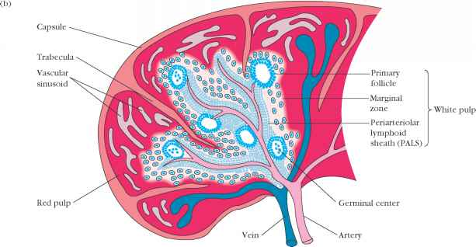

Question 3

Which of the following is one of the many functions of smooth endoplasmic reticulum (SER)?

A Cell protein synthesis
B Cellular cytochrome oxidases
C Cell ribosomal synthesis
D Cell lipid production

Explanation D

The function of the smooth endoplasmic reticulum includes steroid synthesis, carbohydrate metabolism, drug metabolism, calcium regulation, lipid synthesis and gluconeogenesis.

Extra
Rough Endoplasmic Reticulum

The rough endoplasmic reticulum manufactures membranes and secretory proteins. In certain leukocytes, the RER produces antibodies. In pancreatic cells, the RER produces insulin. The rough and smooth ER are usually interconnected and the proteins and membranes synthesised by the RER move into the smooth ER to be transferred to other locations.

Smooth Endoplasmic Reticulum

The SER has a wide range of functions including carbohydrate and lipid synthesis. It serves as a transitional area for vesicles that transport ER products to various destinations. In liver cells the SER produces enzymes that help to detoxify certain drugs. In muscles the SER assists in the contraction of muscle cells, and in brain cells it synthesizes male and female hormones.

Question 4

Which of the following cell organelles have no phospholipid bilayer membrane?

A Rough endoplasmic reticulum
B Lysosome
C Centriole
D Mitochondrium

Explanation C

All the organelles except the centriole have phospholipid bilayer membranes. The walls of each centriole are usually composd of nine triplet of microtubules-protein of the cytoskeleton.

Question 5

Which of the following is a feature of mitochondria?

A Are present in red blood cells
B Are responsible for protein synthesis
C Have no outer cell membrane
D Are self replicative

Explanation D

Mitochondria are not present in red blood cells (RBC) which use the glycolytic pathway. Mitochondria are responsible for the production of adenosine triphosphate (ATP) through cellular respiration and to regulate cellular metabolism. Mitochondria have a bi-lipid membrane

Question 6

Which of the following substances is not subject to passive diffusion?

A Na
B K+
C H20
D PO4

Explanation C

Note: Water is not subject to diffusion, but rather, osmosis.

Osmosis is the diffusion of water molecules across a selectively permeable membrane. The net movement of water molecules through a partially permeable membrane from a solution of high water potential to an area of low water potential.

Question 7

Regarding ribosomes, which of the following statements is correct?

A They are 65% DNA
B They synthesize haemoglobin
C They contain 30% DNA
D They have 3 subunits

Explanation B

Ribosomes are made from complexes of RNAs and proteins. Ribosomes are divided into two subunits composed of 65% ribosomal RNA and 35% ribosomal proteins (known as ribonucleoprotien or RNP). Ribosomes are the workhorses of protein synthesis translate mRNA into protein.

Prokaryotes have 70S ribosomes, each consisting of a small 30S and a large 50S subunit. Eukaryotes have 80S ribosomes, each consisting of a small 40S and large 60S subunit

Question 8

Which of the following is not a function of the smooth endoplasmic reticulum (SER)?

A Protein synthesis
B Drug detoxification
C Steroid synthesis
D Carbohydrate metabolism

Explanation A

The function of the smooth endoplasmic reticulum includes steroid synthesis, carbohydrate metabolism, drug metabolism, calcium regulation, lipid synthesis and gluconeogenesis.

The rough endoplasmic reticulum is responsible for protein synthesis

Question 9

DNA, which is INCORRECT?

A Base paring occurs between A-G and C-T
B A nucleotide consists of a sugar, base and a phosphate group
C Contains 4 different types of bases
D Has two strands (double helix) joined by hydrogen bonds

Explanation A

DNA consists of two long polymers of simple units called nucleotides, with backbones made of sugars and phosphate groups joined by ester bonds. Primarily two forces stabilize the DNA double helix: hydrogen bonds between the bases attached to the two strands. Aromaticnucleobases- Purines: Adenine and Guanine and Pyrimidines: Cytosine and Thymine.

Together, a base, sugar, and phosphate are called a nucleotide.

In a DNA double helix, each type of nucleobase on one strand normally interacts with just one type of nucleobase on the other strand. This is called complementary base pairing. Here, purines form hydrogen bonds to pyrimidines, with A bonding only to T, and C bonding only to G. This arrangement of two nucleotides binding together across the double helix is called a base pair. As hydrogen bonds are not covalent, they can be broken and re-joined relatively easily. The two strands of DNA in a double helix can therefore be pulled apart like a zipper, either by a mechanical force or high temperature

