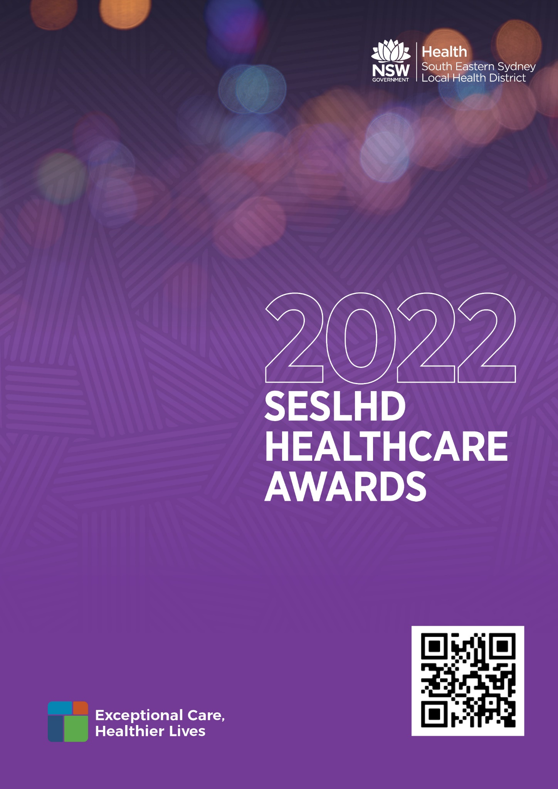

2022 SESLHD HEALTHCARE AWARDS

The SESLHD Healthcare Awards recognise innovation and excellence in the delivery of health programs and services within SESLHD. In these extraordinary times we take this opportunity to recognise and acknowledge the achievements of our staff and SESLHD community. The SESLHD awards this year will continue to be simplified, streamlined and recognise the need for a COVID-safe approach. In 2022, the awards will continue to focus on meeting the objectives of the NSW State Health Plan 2022 and ensuring the long-term sustainability of our healthcare system. This will be achieved through innovation in delivering an integrated health system, creative partnerships and improving efficiencies to support better health for the people of SESLHD.

Team Awards

- Integrated Value Based Care Award
- Excellence in Aboriginal Healthcare Award
- Excellence in the Provision of Mental Health Services Award
- Health Research and Innovation Award
- Keeping People Healthy Award
- Patient Safety First Award
- People and Culture Award
- Transforming Patient Experience Award
Individual Awards

- Collaborative Staff Member of the Year Award
- Volunteer of the Year Award
Peak Awards

- Board Member’s Choice
- Consumer’s Choice for Person Centred Care

Key Dates

SESLHD Healthcare Awards - Open | Tuesday 17th May 2022
Closing date for entries to Local Awards Advisor for site/directorate winners’ selection and GM/Director endorsement | To be confirmed by Site
SESLHD Healthcare Awards - Close  All entries must come via the facility Awards Advisor | Friday 17th June 2022
SESLHD Selection panels convene | Week commencing 27th June 2022
SESLHD Healthcare Awards Ceremony | TBC late July

Submitting an Application

The SESLHD Healthcare Awards recognise innovation and excellence in the delivery of health programs and services to the SESLHD community. Staff are encouraged to submit applications using the entry template which can be download from https://www.seslhd.health.nsw.gov.au/seslhd-healthcare-awards
Entrants need to select submissions carefully, taking into account the Guide to Award Categories, Judging Criteria and other entry requirements. It is the responsibility of entrant to submit projects into the most relevant award category, which is an explicit factor in judging.

For further information and support with completing your application, please contact your local awards advisors.

Healthcare Awards Local Advisors –
Facility | Advisor | Phone
Prince of Wales Hospital | Collette Coughlin | 9382 3030
Sydney / Sydney Eye Hospital | Ann Hodge | 9382 7542
Royal Hospital Women | Maxine Hamilton | 9382 6822
War Memorial Hospital | Ashleigh Webster | 9369 0335
St George Hospital | Sandra Grove and Marg Kalatzis | 9113 2187
Sutherland Hospital | Josie Julian | 9540 8489

Facility | Advisor | Phone
Garrawarra Centre | Cathy Wynn | 8545 4700
Calvary Hospital | Robyn Williams | 9553 3017
Mental Health Services | Stephanie North | 9113 4083
Population and Community Health | Jessica Liew | 8748 9352
District Services | Samara Lampard | 9540 8581

Four steps to completing your submission
- Check that your project is suitable for entry and select a category
- Read and follow the entry requirements
- Use the official template
- Submit to your local awards advisor

Selection Process

- Each facility/directorate is permitted to submit one finalist in each category for the Team Awards and Individual Awards. A selection panel will be facilitated locally to coordinate this process. You will need to ensure that your award is submitted to your local award advisor.
- Facility/directorate finalists must be submitted to the Local Health District by Friday 17th June 2022.
- A Local Health District selection panel will meet week commencing 27th June 2022.
- The Local Health District selection panel will nominate the winner in each category.
- Winners in each category will be announced at a ceremony in July, date to be confirmed.

2022 NSW Healthcare Awards

Winners from the relevant SESLHD Healthcare Awards will be submitted as finalists for the 2022 NSW Health Awards which closes in August 2022.

AWARD CATEGORIES

There are 10 Award Categories

TEAM AWARDS

- Integrated Value Based Care

This Award includes last year’s Delivering Integrated Care Award and recognises initiatives that support SESLHD’s vision for a sustainable health system that delivers outcomes that matter to patients, is personalised, invests in wellness and is digitally enabled. The move to value is being accelerated through local initiatives and state-wide programs including Leading Better Value Care (LBVC), Integrated Care and Commissioning for Better Value. The nominations for this category will need to demonstrate that they are improving the different aspects of value:
- demonstrated approach to ensuring equity of access to the service
- health outcomes that matter to patients
- the experience of receiving care
- the experience of providing care
- the effectiveness and efficiency of care.

The award acknowledges innovative projects and programs which promote:
- building new and innovative partnerships between the public, private and/or non-government sectors to ensure access to the best possible health care for all residents of NSW
- partnering with community-based organisations to provide services for patients in the community
- defining business models for purchasing services and creating sustainable incentives for both purchaser and provider leading to improved patient outcomes, productivity and efficiencies
- creating formal links between primary, community and hospital services to deliver health care that meets the needs of patients over time and delivers the best possible health outcomes
- care provided in appropriate, cost effective settings that are close to home, keeping people well and out of hospital wherever possible
- seamless transitions between hospital, primary, community, residential and aged care settings
- innovative funding models, governance arrangements, and information technology solutions that support a sustainable, integrated system of care
- engaging consumers and clinicians to develop person-centred models of care that are efficient, effective and sustainable, and promote individual responsibility for health
- partnerships which demonstrate and promote CORE values through the provision of integrated care across organisations in partnership with clinicians, patients and their families and carers.

- Excellence in Aboriginal Healthcare Award

Excellence in Aboriginal Healthcare is a new award that recognises exceptional healthcare delivery through strong partnerships across NSW Health and external agencies. This may include:
- valuing and fostering respect for the expertise and knowledge of ACCHSs and their staff.
- collaboration in designing and delivering services.
- sharing of resources.
- strong consultation and communication mechanisms.
- strategic collaboration or partnership in the development of the project.
- responsiveness to the local Aboriginal community's health needs, as identified by the local Aboriginal Health
- capacity building and employment of Partnership Agreement or Aboriginal Health LHD Action Aboriginal people.
- partnership with the Aboriginal people and communities in the design, implementation, evaluation and evidence building.

3. Excellence in the Provision of Mental Health Services

Mental Health is a priority area for the NSW Government and SESLHD. This award recognises and showcases innovation in improving the quality and safety of mental health patient care within programs which display:

- Best practice, excellence and innovation in mental health service delivery
- Development of consumer-focused services
- Positive mental health and wellbeing through consumer and carer participation
- Improved prevention and early intervention.

4. Health Research and Innovation

SESLHD is committed to translating research and innovation into clinical service models that deliver positive health outcomes for our community. As part of this commitment, SESLHD aims to build research and innovation capacity and capability within SESLHD, increase community access to research and innovation and foster a culture of innovation, research and translation within SESLHD.

Collaboration between researchers, policy makers, service users, health managers and clinicians in research is critical and can lead to findings that are more likely to be innovative and positively inform health decisions. This includes innovative future focused infrastructure and digital health initiatives.

Awardees may have demonstrated outstanding and innovative achievements by establishing:
- Ways of assisting clinicians and health decision makers to find or use research effectively
- Research partnerships or collaborations involving clinicians, health service providers, decision makers and/or consumers that have led to outstanding examples of research that changed policy or practice
- Acknowledgement by decision makers of the impact of research on their policy or practice

- eHealth, health information and data analytics to support and harness health & medical research and innovation.
- Clinical practices and processes delivered through innovative built spaces including new approaches to effective and efficient building outcomes to deliver clinical outcomes.

5. Keeping People Healthy

SESLHD is committed to promoting good health through raising awareness of healthy choices, preventing ill health and improving the overall health and wellbeing of the community. A key strategic priority as part of the SESLHD Journey to Excellence 2018-2022 is to work together with our partners to achieve health, wellbeing and equity for our shared communities.

The Keeping People Healthy award, formally The Harry Collins Award, has previously commemorated the outstanding commitment and passionate contribution of Mr Henry (Harry) Collins. Harry made a particularly outstanding contribution to the “Clean Hands Save Lives” Campaign prior to his death in November 2007. This campaign is an example of a Keeping People Healthy initiative. His dedication to bringing the community’s perspective to the prevention of Healthcare Associated Infections is greatly appreciated by both patients and staff of the NSW Health system and NSW Health is proud to recognise these achievements. This award aims to acknowledge similar innovative projects and programs which promote:

- Reducing negative health impacts through improvements in environmental health
- Action to support individuals, families and communities to make healthy lifestyle choices
- Closing the gap in Aboriginal health outcomes
- Improving lifestyles by targeting public health priorities such as tobacco control, physical activity, obesity, infectious disease, oral health, diabetes prevention and addressing harmful risk factors
- Identifying and improving health outcomes for risk groups, e.g. children, youth, older people, workers and disadvantaged groups
- Primary, secondary and population health prevention
- The integration of the CORE values in promoting healthy living.

6. Patient Safety First

In SESLHD our goal is for everyone in our community to have access to safe, compassionate and high quality healthcare. In addition, we continue to focus on fostering innovation and translational research into clinical service models to deliver positive health outcomes. Providing world-class clinical care where patient safety comes first, is a key priority for NSW Health and SESLHD. NSW Health has a shared vision that Patient Safety is everybody’s business. This award acknowledges a commitment to putting patient safety first every day. Projects within this category will display patient safety first in:

- Leading quality improvement to ensure safer patient care
- Delivering innovative approaches to improving patient safety
- Engaging patients in approaches to improve patient safety
- Demonstrating leadership or role modelling behaviour that puts patient safety first.

7. People and Culture Award
Bringing together two awards, a safe and healthy workplace and supporting our people, the People and Culture Award recognises teams who develop and support our people and culture and ensure a safe and healthy environment for patients and staff. Initiatives within this category will show support for people within NSW Health by:
- working collaboratively within the NSW Health system to improve health outcomes
- growing and supporting a skilled workforce by hiring and developing the right people, with the right skills, at the right time
- developing effective health professional managers and leaders
- improved systems and efficiencies to support better workplace safety and health outcomes
- ownership and adoption of workplace health and safety practices
- support for long-term behaviour change to strengthen the staff health safety culture
- increased awareness of the importance of personal safety alongside patient safety
- enhanced access and training in workplace health and safety
- fostering a culture that reflects the NSW Health CORE values and respects diversity.
8. Transforming Patient Experience

Partnering with our community is a critical component of our transformation strategy, SESLHD Journey to Excellence 2018-2022. This award recognises that patients are partners in their health care and aims to acknowledge projects/programs which promote collaboration between the patient and the health care team to improve health. Entries should be able to demonstrate innovation in:

- Empowering patients to take control of their health and be supported in managing their own health conditions
- Shared decision making; the patient is an expert in their own values and needs
- Clinicians planning and delivering care in partnership with the patient
- Enhancing access to patient centred care for people living with chronic illness
- Promotion of CORE values in all patient interaction
- Engaging consumers in strategic planning and governance processes.

INDIVIDUAL AWARDS

9. Collaborative Staff Member of the Year

This award brings together two individual awards, staff member of the year and collaborative leader of the year. It aims to recognise NSW Health employees who have made an exceptional contribution through effective collaboration to the NSW health system. This award aims to acknowledge an individual who:

- as part of their clinical or support role in NSW Health, provides excellence in service to support staff, patients, carers or families
- is a role model for promoting positive cultural change and inspiring other staff within NSW Health
- uses new and innovative ways to collaborate with staff, patients, carers or families.
- supports effective teamwork to collaboratively to improve patient care
- strong corporate and clinical governance and CORE values in all health services

10. Volunteer of the Year Award

The Volunteer of the Year Award recognises the significant contribution of an individual to volunteering within SESLHD. This award aims to acknowledge an individual who:

- Provides excellent support for patients, carers and families
- Acts as a role model for volunteering in SESLHD which promotes volunteer services and inspires other volunteers
- Uses new and innovative ways to engage patients, carers and families.

PEAK AWARDS

Staff cannot apply for a Peak Award. The Peak Awards are selected from all of the applications submitted within the Main Awards Categories.

11. Board Member’s Choice

This award is selected by the SESLHD Chairman of the Board from all of the applications submitted in the Main Awards Categories.

12. Consumer’s Choice for Person Centred Care

This award is selected by a nominated SESLHD consumer for excellence in person centred care.

AWARD CRITERIA Categories 1-8
TEAM AWARDS
The award criteria and weighting relating to each award category is provided below. This information should be taken into consideration when compiling submissions.
- Integrated Value Based Care Award
- Excellence in Aboriginal Healthcare Award
- Excellence in the Provision of Mental Health Services Award
- Health Research and Innovation Award
- Keeping People Healthy Award
- Patient Safety First Award
- People and Culture Award
- Transforming Patient Experience Award

CRITERIA |  | POINTS
Innovation and originality | The extent to which the project/program demonstrates an original or innovative approach (new or known) to an existing issue. If the project/program is using a known innovation, the extent to which it has been implemented differently/innovatively.  The project should show resourcefulness and creativity. It may include workforce or other innovation and use of enabling technologies with support for a sustainable service model. | 25
Sustainable and scalable | Evidence showing the project/program has resulted in systemic and tangible changes which are embedded within the organisation and are sustainable over time. Identifies/demonstrates the extent to which the project/program is scalable, able to be replicated and has been (or has potential to be) successfully transferred to other health services/settings. | 20
Better patient or community outcomes | Evidence showing how the project/program has improved outcomes for patients and community groups. This may be either direct or flow-on depending on the nature of the project. For example, reduced length of stay or reduced morbidity. This can also focus on better outcomes in the community, including social and emotional wellbeing. | 20
Team work, partnership and CORE Values | The extent to which the project/program demonstrates and promotes the CORE Value- Collaboration, Openness, Respect and Empowerment. | 20
Productivity and value for money | The project /program demonstrates evidence-based improvement in productivity and efficiency/value for money | 5
Logical coherence and rigour | The overall logic of the submission and the rigour of the method and results are clear. | 5
Quality of Presentation | The overall clarity of expression and organisation of the material presented in the submission is sound. | 5
TOTAL |  | 100

AWARD CRITERIA Categories 9 and 10
INDIVIDUAL AWARDS
The Award Criteria and weighting relating to each award category is provided below. This information should be taken into consideration when compiling submissions.
- Collaborative Staff Member of the Year Award
- Volunteer of the Year Award
CRITERIA |  | POINTS
Provides Excellent Services | As part of their clinical or support role in SESLHD, provides excellence in service and support for staff, patients, carers or families. | 30
Positive Cultural Change | Acts as a role model for promoting positive cultural change and inspiring other staff/volunteers within SESLHD. | 30
Innovative Approaches | Evidence that the individual uses new and innovative ways to engage staff, patients, carers or families. | 30
CORE – Collaboration, Openness, Respect and Empowerment | The staff member/volunteer demonstrates a commitment to promoting/demonstrating any, or all of, the CORE values of Collaboration, Openness, Respect and Empowerment. | 10
TOTAL |  | 100

Submission Process and Condition of Entry
Submission Process
- Awards are open to all SESLHD organisations either individually, in partnership or in conjunction with a lay partner. Each SESLHD organisation can only enter one project in each category, with the same entry not permitted to be submitted in multiple categories.
- Each SESLHD organisation will be responsible for selecting their submissions to be entered in the 2022 SESLHD Healthcare Awards.
- The most relevant category should be selected with the entry carefully checked against the criteria and entry requirements.
- Once the application is complete it should be submitted to your local Awards Liaison Officer. Awards submissions will only be accepted through Award Liaison Officers.
- Entries will be accepted from Tuesday 17th May 2022 with closing of submissions at 5.00 pm on Friday 17th June 2022.
- Only entries signed off by the General Manager/Director and submitted electronically will be accepted. Submissions from individuals/teams directly to Strategy, Innovation and Improvement will not be accepted.
Conditions of Entry
- Entries will be accepted by your local award liaison officer from Tuesday 17th May 2022 and must be to LHD by Friday 17th June 2022.
- Entries are to be submitted electronically. Details of the online submissions system will be provided directly to the SESLHD Healthcare Awards Liaison Officers.
- Entries must be carefully checked for accuracy and compliance with the Submission Process and Conditions of Entry.
- Entries must adhere to style guidelines – Appendix 1: Style Guidelines.
- Entries will be assessed by a judging panel, the decisions of which are final. No correspondence or discussion will be entered into.
- Each entry will be considered within one category only and will be judged in the category to which it has been submitted. Selection of the most relevant category for each entry is entirely the responsibility of each facility/directorate.
- Submissions that do not comply substantially with entry requirements or are not sufficiently relevant may not be judged.
- Submissions must adhere strictly to the word limits within the application. Applications which exceed the word limit will not be judged.
- Previous entries are not to be re-submitted. However, where significant new developments have taken place e.g. follow-up outcome evaluation of a previous project, an entry may be made providing that:
- Substantial work involving new information, concepts or initiatives are presented;
- The entry focuses on the new work rather than re-presenting previous work; and
- It is at least 3 years since the previous entry.
- Awards will not necessarily be given in all categories.

Appendix 1: Style Guidelines
The following style guidelines must be followed for all category submissions.
Style
- Use Arial font size 10
- Use simple, direct and correct common Australian English spelling
- Avoid the use of “inverted commas”, italics, bold type or underlining
- The headings of each section of the submission should be presented without punctuation, without underlining or bold type, capitalising only the first letter
- Use gender-neutral language
Tables and graphics
Tables and graphics are to be included as separate attachments. These should be clearly referenced in your submission. If large graphics or images are to be attached please compress them to reduce the file size to fewer than 3MB to facilitate electronic submission. Supported formats are .pdf or .doc, .xls, .xlxs, .docx, .jpg, .jpeg or .png format.
Written permission
Written permission should be obtained for reproduction of previously published figures and tables.
References
When referring to other publications in the text, state the author’s name followed by the date of the publication. List full details of the publication in a reference list at the end of the submission utilising the Harvard Referencing Style.
Compliance with requirements
Entries that do not substantially comply with these requirements will not be judged

