Chronic Wound Clinic Referral
2/531-533 Kingsway, Miranda, Level 1
NOTE: This clinic only operates on Thursday afternoons
For enquiries leave a message on XXXXXXXXXX & we will call back
This clinic provides an ambulatory care clinic and tele-health appointments.
All initial appointments will be tele-health.
Workup studies (document or attach):
- Swab reports________________________________________________________
- FBC________________________________________________________________
- Iron________________________________________________________________
- HbA1c______________________________________________________________
- LFT & EUC__________________________________________________________
Other important studies (useful to have results if already conducted)
- Has a biopsy been done? Yes (please document results below) No
Histopath results _______________________________
- Venous & Arterial dopplers (for leg ulcers/wounds) ________________

Patient Details | GP / Specialist Referrer Details
Name: | Name:
DOB: | Practice:
Address: | Phone:
Patient phone: | Fax:
Who do we contact to make this appointment?
Contact Name & phone: Relationship to patient:
Referral criteria (these all need to apply, otherwise referral will not be accepted)
 Chronic or complex wound
 Greater than 6 weeks duration
 Wound is failing to heal despite usual treatment
 GP has consulted on this wound and approves this referral
 Patient can attend the clinic- must be able to transfer with minimal assistance of one person
OR
Tele-health appointment required as patient CAN’T transfer easily with one or less people
Past History: Please attach a GP patient health summary with this referral which includes:
- Past History
- Current Medications
Allergies (list specific allergen/s and reaction/s) Nil allergies……………………………………
Latex……………………………………..…….. Tape……………………..….…………………
Local anaesthetic……………………………... Iodine…………………………………………..
Medications………………………..………… Other…………………………………………….
…………………………………………………… …………………………………………………..
Does the patient have any of the following:
 Diabetes  Anaemia Anticoagulants
 Arterial disease  Venous disease  Immunosuppresents
 Lymphoedema  Renal Failure  Steroids
 Heart Failure  Peripheral Neuropathy  Chemotherapy
Hypertension  Dementia  Malignancy
 Previous leg ulcers- If yes for previous ulcers, what type and how long ago: ………………………………………………………………………………………………………….
…………………………………………………………………………………………………………...

Please mark location of all current wound/s
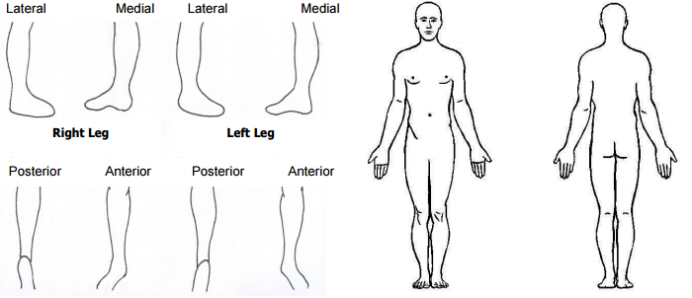

Details of current wound/s needing review:
How many wounds do you want this clinic to focus on? Please number on above drawings.

Duration of each wound

Dressings- frequency & type

Pain- severity & type

Have any specialists been involved in care? What did they do?

Who is managing this wound? (include contact details)

Has the patient’s usual GP been notified of this referral? Yes - if not please do so prior to sending referral.

Please fax this form back to 9540 8164.
Referrals will be responded to within 1-2 weeks of receiving referral.

