 | 
2025 SESLHD Nursing and Midwifery
Order form - Strengths, Positive Thoughts & Affirmation cards
Please complete all sections, scan and return to SESLHD-NursingandMidwifery@health.nsw.gov.au
First Name
Surname
Local Health District
Facility / Site:
Contact Number:
Email Address:
Number of sets of cards required :
Date funds transferred:
Transfer receipt number or screen shot

Payment portal QR code:
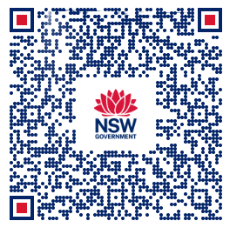
Cards Cost $25 AUD + $10 Postage AUD (Postage fee for outside South Eastern Sydney Local Health District) (incl. GST)

Please note – No refunds are payable

