EXPRESSION OF INTEREST
EMERGING NUM PROGRAM 2020
Are you a future Nursing Unit Manager?
Have you ever thought you might like to lead and manage a clinical unit?
Do you accept the Nightingale challenge?

We are seeking expressions of interest from Registered Nurses who are current employees of Prince of Wales who are interested in completing a NUM training program for future relief and promotional opportunities.

The Nightingale challenge asks every health employer around the world to provide leadership development support and education for emerging nursing leaders under the age of 35. SESLHD is excited to accept this challenge. You can participate through enrolling on this course. More information is available at www.seslhd.nsw.gov.au/nightingale-challenge

If you are interested in pursuing a career in management then this would be a great opportunity to gain the experience and skills through a supported training program. This is the first program of its kind at Prince of Wales Hospital and we are hoping to create a team of dedicated and effective leaders.

You will be given the tools and skills from key nursing management personnel and service providers across the organisation through a robust 12 month orientation and training program. You will have the opportunity to work in a position alongside a NUM working at Prince of Wales Hospital.

Essential criteria:

- Registered Nurse with current National registration with AHPRA
- 3 years full time post graduate acute care nursing experience
- Current employee at Prince of Wales Hospital
- Willingness to complete a 3 week full time orientation and training program and attend monthly workshops throughout the year
- Demonstrated engagement in professional development

Please send your current CV and expression of interest including the following:

- 3 key management qualities you consider essential for leading and how they apply to you
- 2 examples outlining how you have managed a problem in your unit
- Written support from your current line manager

The 3 week Orientation and training program is scheduled to commence on 3 February 2019 with workshops to follow throughout the year.
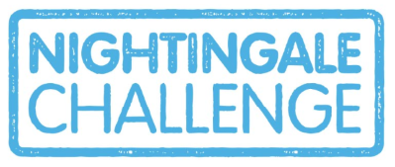
Applications to:
Ildiko.Greener@health.nsw.gov.au
Executive Assistant to Director of Nursing Tel: 9382 0497

Closing date: Wednesday 18 December 2019

Enquiries to
Belinda.Rabet@health.nsw.gov.au or Sheemol.Barrett@health.nsw.gov.au
Tel: 9382 0497

