 | 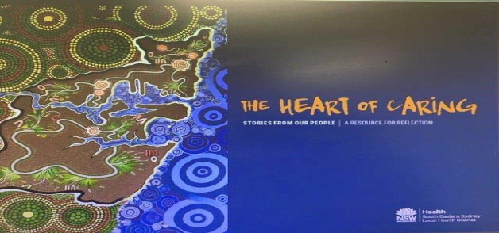 | 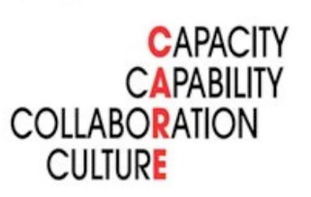
2020 SESLHD Nursing and Midwifery Forum
Order form - Heart of Caring Reflective Resource Book (Edition 2)
Please complete all sections, scan and return to SESLHD-NursingandMidwifery@health.nsw.gov.au
First Name
Surname
Local Health District
Facility / Site
Preferred postal address:
Contact Number
Email Address
Number of books required
Date funds transferred
Transfer receipt number
Credit Card
Payment Details: Visa /Mastercard ( Please circle)
Credit Card Number _ _ _ _ _ _ _ _ _ _ _ _ _ _ _ _
Expiry Date : __/__ Name on Card : Amount :
Signature :______________________________________________________

Book Cost $15 AUD + $10 Postage AUD (Postage fee for outside South Eastern Sydney Local Health District)
(Incl. GST)

Bank transfer details: Westpac Bank
BSB: 032 099
Account Number: 520765
Account Name: South Eastern Sydney Local Health District
Reference: ‘Initial, Last Name – Heart of Caring Book
(For example: J Brown – Heart of Caring Book)
Please note – No refunds are payable

