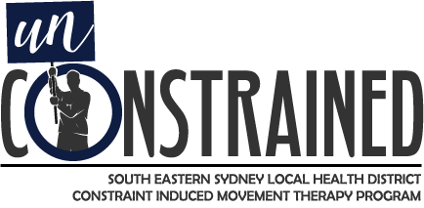


Have you or someone you care for had a stroke?
Do you have one arm that is weak or that you tend not to use?
You are not alone. Up to 80% of people have some arm and hand use disability after a stroke.
Constraint Induced Movement Therapy may be right for you!
What is it?
Constraint Induced Movement Therapy (CIMT) is a well-researched treatment method that can be used to recover some of the lost function from the weak arm.
During the program we aim to help you to use your weaker arm by stopping you from using the stronger arm and helping you to gain back some of your function.
Not everyone is suitable for the program, but the right candidates will achieve improved use of their weak arm by the end of the program.
CIMT is an intensive program and requires your full commitment. It is a gold standard treatment and is recommended in the living stroke guidelines.
What can I expect?
The program is intensive and is run by Physiotherapists and Occupational Therapists at Prince of Wales Hospital, St George Hospital and Sutherland Hospital.
- You will attend a clinic for 4 hours of daily arm therapy for 2 full weeks (however you will get weekends off).
- You will need to attend for a pre-assessment a few days before your start date and a post-assessment a few days after you finish. These times will be scheduled with you.
- You will be asked to complete some homework tasks and also to wear a glove or a sling on your good arm most of the time during your program (even at home!).
- Once your two weeks are completed you can go back to your normal life, hopefully with more arm function of that weaker arm. We will encourage you to keep using your weaker arm once you return home.
Am I eligible?
- For this therapy to work you need to have some movement in your weaker arm. You will need to be able to purposefully bend your wrist back and open your fingers a little bit. You will also need a bit of shoulder and elbow movement.
- You need to be able to manage to get to and from the toilet by yourself (or if you need a carer they will need to come with you).
- You will need to commit to the full program and its requirements.
- You will need to arrange transportation to and from the hospital each day. If this is a major concern for you, feel free to contact us so that we can discuss it.
- If you think that you are eligible, we will need to see you to make sure that we can offer this therapy to you.

Check the website for further information and to refer yourself to the program at: https://seslhd.health.nsw.gov.au/services-clinics/directory/constraint-induced-movement-therapy-cimt

Email your enquiries to: SESLHD-Sutherland-CMTReferrals@health.nsw.gov.au

Or phone your closest site and ask about CIMT:
Prince of Wales Hospital: 9382 5190
St George Hospital: 9113 2395
Sutherland Hospital: 9540 7475

