Question 1
Which of the following does NOT impair wound healing?
Your answer was correct
- A Lack of insulin
- B Vitamin A deficiency Correct Answer
- C Glucocorticoid excess
- D Vitamin C deficiency

Explanation
I have chosen to keep this question as is.
If you look in the current TB, it states that infection, diabetes, nutritional –vit C deficiency, mechanical factors, glucocorticoids, poor perfusion, FB, type and extent of injury and the location of injury are all factors impairing wound healing.
Vitamin A deficiency: night blindness, epithelial metaplasia and keratinization-of the eyes: xeropthalmia. Upper respiratory and urinary tract undergo squamous metaplasia. Hyperplasia and keratinization of the epidermis leading to follicular or popular dermatosis. Another serious consequence is immune deficiency.
It does not speak about wound healing directly. I have therefore chosen vit A as the most likely answer. Please see extensive note about vitamin A form a new resource
It’s not news that diet plays an important role in the body’s capacity for wound healing. Many people are aware that fats, protein, carbohydrates and zinc are necessary for the development of new tissue. However, one often overlooked nutrient is vitamin A. According to the University of Maryland Medical Centre, vitamin A aids cells in the reproduction process, known as cellular differentiation. This is an integral part of wound healing, as cellular reproduction must occur for new tissue to grow. Vitamin A also helps reduce the risk of wound infection, as it is essential to proper immune system function, and the nutrient helps manage inflammation that occurs after a wound is sustained.
Factors Affecting Wound Healing:
- Local Factors
- Systemic Factors
- Oxygenation
- Infection
- Foreign body
- Venous sufficiency
- Age and gender
- Sex hormones
- Stress Ischemia
Diseases: diabetes, keloids, fibrosis, hereditary healing disorders, jaundice, uraemia Obesity Medications: glucocorticoid steroids, non-steroidal anti-inflammatory drugs, chemotherapy Alcoholism and smoking Immunocompromised conditions: cancer, radiation therapy, AIDS Nutrition

Question 2
With regard to healing by first intention, which of the following options is correct?
Your answer was correct
- A Myofibrils account for the majority of wound strength
- B Neutrophils accumulate at the wound margins at the same time as epithelial proliferation Correct Answer
- C Collagen deposited early in granulation tissue is type I
- D Neovascularisation is maximal by day three

Explanation
Within 24 hours, neutrophils appear at the margins of the incision, moving toward the fibrin clot. They release proteolytic enzymes that clean out debris and invading bacteria. The epidermis at its cut edges thickens as a result of mitotic activity and within 24-48 hours, spurs of epithelial cells from the edges both migrate and grow along the cut margins of the dermis. Neovascularisation is maximal by the 5th day. Collagen type III is initially laid down and then replaced by the stronger collagen type 1. Wound strength at one week is 10% and at 3 months 80% but in never reaches 100% of pre-injury levels. Type 1 collagen accounts for most of the wound strength.

Question 3
Which of the following statements is NOT characteristic of platelets?

Your answer was correct
- A They contain alpha and delta granules
- B They are biconvex discs
- C They contain a nucleus Correct Answer
- D They are found in the plasma at levels of 200-500 thousand per microlitre

Explanation
Platelets have membrane-bound smooth biconvex discs and do not have a nucleus. They are shed from megakaryocytes in the bone marrow into the blood. Platelets play a critical role in haemostasis. They contain alpha granules (containing: fibrinogen, fibronectin, factors V and VIII, platelet factor 4, PDGF and transforming growth factor B) and delta granules (containing: ADP and ATP, ionised calcium, histamine, serotonin and adrenaline). They are found in the plasma at levels of 200-500 thousand per microlitre. Some texts say 300 thousand per microlitre. The average lifespan of a platelet is normally 5 to 9 days. After vascular injury, platelets encounter extracellular matrix substances such as collagen and glycoprotein vWF. On contact with these proteins, platelets undergo adhesion (shape change), secretion (release reaction) and aggregation.

Question 4
Macrophages secrete all of the following except?
Your answer was not correct
- A Oxygen free radicals
- B Histamine Correct Answer
- C Prostaglandins
- D Coagulation factors Your Answer

Explanation
Macrophages are the dominant cellular player in chronic inflammation. The products of activated macrophages serve to eliminate injurious agents such as microbes, and to initiate the process of repair. They are responsible for much of the tissue injury in chronic inflammation. The products produced by macrophages, which cause tissue injury and fibrosis, are: arachidonic metabolites, reactive oxygen species, reactive nitrogen species, proteases, cytokines and coagulation factors. The factors they release which cause repair include; growth factor, fibrogenic cytokines, angiogenic factors and remodeling collagenesis.

Question 5
Which of the following cells cannot phagocytose?
Your answer was not correct
- A T-cells Correct Answer
- B Neutrophils
- C Macrophages
- D Eosinophils Your Answer

Explanation
Phagocytes are divided into "professional" and "non-professional" groups based on the efficiency with which they participate in phagocytosis. The professional phagocytes are the monocytes, macrophages, neutrophils, tissue dendritic cells and mast cells. One litre of human blood contains about six billion phagocytes.

Question 6
Concerning the repair of a well opposed, clean, surgical incision, which of the following statements is correct?
Your answer was correct
- A 20% of original tissue strength is attained after 1 week
- B Dermal appendages destroyed by the incision usually recover
- C There is an initial inflammatory response Correct Answer
- D New collagen begins to accumulate after the first week

Explanation
Dermal appendages destroyed by the incision do not recover. New collagen deposition occurs by day 3 of wound healing. Granulation tissue progressively invades the wound space by day 3 of healing. Wound strength is usually 10% by the end of the first week.

Question 7
Which of the following occurs first in fracture healing?
Your answer was correct
- A Collagen deposition
- B Neutrophil invasion Correct Answer
- C Woven bone ossification
- D Procallus formation

Explanation
The clot provides a mesh which creates a framework for the influx of inflammatory cells

Question 8
In bone fracture healing, which of the following statements is correct?
Your answer was not correct
- A In the remodelling phase, osteoblasts first resorb the lamellar bone before they replace it with compact bone
- B All fractures contain cartilage as a component of the callus Your Answer
- C Endochondral ossification refers to the replacement of hyaline cartilage with lamellar bone Correct Answer
- D Haematoma at the fracture site plays little role in the development of procallus

Explanation
There are 3 phases of fracture healing: reactive phase, reparative phase and remodelling phase
In the reactivephase, the haematoma that forms immediately after a fracture is essential as it surrounds the area of injury, and provides a fibrin mesh, which helps seal off the fracture site and at the same time serves as a framework for the influx of inflammatory cells and ingrowth of fibroblasts and new capillary cells. This sets up the framework for the formation of procallus.
Fracture callus is most often made up of hyaline cartilage and woven bone. However, not all fractures contain cartilage as a component of callus
In the reparative stagethere is replacement of the hyaline cartilage and woven bone with lamellar bone. The replacement process is known as endochondral ossification with respect to hyaline cartilage and bony substitution with respect to woven bone.
In the remodelling phase, the trabecular bone (which replaced the lamellar bone) is resorbed by osteoclasts, creating a shallow pit- Howship's lacuna"- into which osteoblasts deposit compact bone which is remodelled into shape which closely resembles the bone's original shape and strength

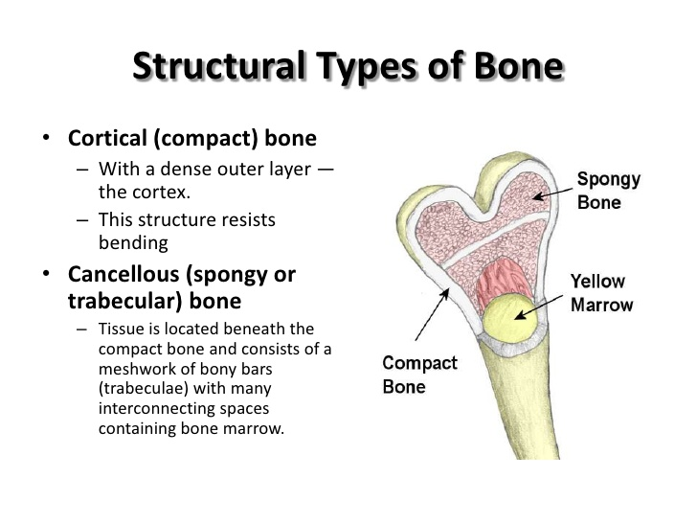

Question 9 ???
In healing by primary intention, which of the following statements is correct?
Your answer was not correct
- A An epithelial spur forms on the first day Correct Answer
- B There is a large tissue defect
- C It involves excessive granulation tissue
- D The tissue defect cannot be reconstituted Your Answer
Spur forms 24-48hrs!

Question 10
Which of the following statements regarding mast cells is correct?
Your answer was correct
- A They are involved in acute but not chronic inflammation
- B They may discharge independent of IgE Correct Answer
- C Adenosine diphosphate is a stimulator of mast cell degranulation
- D They release lysosymes

Explanation
Mast cells participate in both acute and chronic inflammatory reactions. Mast cells release multiple primary and secondary mediators but not lysosomes. Adenosine triphosphate provides the energy for mast cell degranulation. Non IgE dependent discharge is called anaphylactoid for instance with drugs (including x-ray contrast material), bacterial toxins, during surgery and with exposure to heat or cold.

