Standard Operating Procedure
This document, including any attachments, is PRIVATE AND CONFIDENTIAL. Do not copy or use it other than in accordance with SESLHD-RO’s written instructions.
SOP Title | Research Ethics and Governance Office Review of Ethics Applications
SOP number | 001-SOP-01 | Version | 1.0
Effective date | 18-Jun-2021 | Supersedes document/s | N/A
Programmed review date |  | 18-Jun-2023

Contents
1. PURPOSE 3
2. SCOPE 3
3. RESPONSIBILITY 3
3.1. HREC 3
3.1.1. LNR Committee 3
3.1.2. Executive Committee 3
3.1.3. HREC Chairperson (or delegate) 3
3.1.4. HREC Member 3
3.2. Executive Officer (or delegate) 3
3.3. Research Ethics and Governance Officer (or delegate) 3
4. DEFINITIONS 4
4.1. Research Types: 4
4.1.1. Clinical Research 4
4.1.2. Clinical Trial 4
4.1.3. Health Research/Social Science 5
4.1.4. Other 6
4.2. Primary Parties Involved in Research 6
4.2.1. Sponsor 6
4.2.2. Coordinating Principal Investigator 6
4.2.3. Principal Investigator 6
4.3. Sponsor Type 6
4.3.1. Commercial Entity 6
4.3.2. Collaborative Research Group 6
4.3.3. Investigator/Institution Initiated 7
4.3.4. Other 7
4.4. Risk Pathway 7
4.4.1. Negligible Risk 7
4.4.2. Low Risk 7
4.4.3. Greater Than Low Risk 7
4.5. National Mutual Acceptance Scheme 7
4.6. CTN Scheme 8
4.7. CTA Scheme 8
4.8. Privacy Requirements 8
4.8.1. Personal Information 8
4.8.2. Health Information 8
4.8.3. Personal Health Information 8
4.8.4. Sensitive Information 8
4.9. Safety Reporting 9
4.9.1. Significant Safety Issues 9
4.9.2. Urgent Safety Measures Resulting from Significant Safety Issues 9
4.9.3. Serious Breaches of GCP 9
5. PROCESS FLOW CHART 10
5.1. Greater Than Low Risk Applications 10
5.2. Processing Amendments 14
5.3. Processing Milestones 15
5.4. Processing Safety Reports 15
6. PROCEDURES 16
6.1. Pre-Approval Activities 16
6.1.1. Eligibility Review 16
6.1.2. Meetings and HREC Management 16
6.1.3. Distribution of Investigator Correspondence 16
6.2. Post Approval Activities 17
6.2.1. Greater Than Low Risk Ethics Amendments 17
6.2.2. Executive Officer Amendments 17
6.2.3. Project Milestones 17
6.2.4. Safety Reporting 17
7. ASSOCIATED DOCUMENTS 17
8. REFERENCES 18
9. RELATED SOPs 18
10. REVISION HISTORY 18
11. APPROVALS 18

- PURPOSE
The purpose of this document is to describe the procedures involved in managing the lifecycle of a research ethics application/project in the South Eastern Sydney Local Health District (SESLHD).
- SCOPE
This Standard Operating Procedure (SOP) applies to all individuals working in the SESLHD-RO that are actively working on research projects that are being reviewed and managed by the SESLHD Human Research Ethics Committee (HREC).
- RESPONSIBILITY
The roles and responsibilities for the parties below are discussed at length in the National Statement, other national standards, and many NSW Health policies (see Section 8).
  - HREC
The SESLHD HREC is an NHMRC certified lead HREC. This governing body has the authority to review and approve research under the National Mutual Acceptance scheme. The HREC is bound to review research for scientific merit and ethical integrity in accordance with the National Statement. The HREC, and its subcommittees, meet at regular intervals and are governed by PD2010_055, GL2010_013, GL2013_009, and the SESLHD HREC Standard Operating Procedure and Terms of Reference (See Section 8).
    - LNR Committee
The Low or Negligible Risk (LNR) Committee is a sub-committee of the HREC that reviews applications and amendments for low/negligible risk research.
    - Executive Committee
The Executive Committee (EC) is a sub-committee of the HREC that reviews delegated responses to full HREC review, study amendments, progress reports, and safety reports.
    - HREC Chairperson (or delegate)
The HREC Chair (or delegate) is responsible for chairing the meetings, reviewing, and approving the minutes, reviewing and adjudicating complaints, and is required to participate on the HREC and EC.
    - HREC Member
HREC members are required to review research applications, review and adjudicate complaints, attend meetings regularly, and consult on ongoing research management as described in Sections 3.1 and 8.
  - Executive Officer (or delegate)
The Executive Officer’s (EO) role is described in detail in GL2010_014 (see Section 8). The EO’s role spans across pre-approval, post-approval, and general HREC management. The EO can approve ethics application responses and amendments as delegated by the HREC and/or the Chair.
  - Research Ethics and Governance Officer (or delegate)
The Research Ethics and Governance Officer (REGO) is responsible for:
- Triaging ethics applications,
- Disseminating greater than low risk applications for pre-review,
- Create meetings for the HREC and its subcommittees,
- Prepare, draft, complete, and distribute meeting agendas and minutes,
- Disseminate HREC (and subcommittee) correspondence,
- Triage and process ethics amendments, safety notifications, and study milestones.
- DEFINITIONS
CPI | Coordinating Principal Investigator
EC | Executive Committee
EO | Executive Officer
GTLR | Greater Than Low Risk
HREA | Human Research Ethics Application
HREC | Human Research Ethics Committee
LNR | Low or Negligible Risk
PHI | Personal Health Information
PI | Principal Investigator
REGO | Research Ethics and Governance Officer
SESLHD | South Eastern Sydney Local Health District
SESLHD-RO | South Eastern Sydney Local Health District – Research Office
TGA | Therapeutic Goods Administration
  - Research Types:
    - Clinical Research
Clinical research includes observational studies in the clinical setting, which are designed to understand, find and treat illnesses, and identify other health issues. These studies involve a wide range of activities from genetics to assisting medical staff and patients to communicate better. Examples include finding how genetics lead to disease or finding the best ways to counsel people who have a genetic mutation that predisposes them to a certain disease such as cancer; disease registries; and, studying the relationship between smoking and heart attacks.
If the clinical research also meets the definition of CT, please only select CT.
    - Clinical Trial
A clinical trial is any research project that prospectively assigns human participants or groups to one or more health-related interventions to evaluate the effects on health outcomes.
Table 1.0: Phases of Clinical Trials in Pharmaceuticals
Pharmaceuticals
Phase | Purpose  Participants | Purpose
0 | Pilot/Exploratory  10-15 | - Test a very small (subtherapeutic) dose of a new drug to study its effects & how it works in the human body.  - Not undertaken by all drugs.
I | Safety & Toxicity  10 - 100 | - True first-in-human study to test safety & toxicity, usually in healthy humans.
II | Safety & Efficacy  100’s | - Assess efficacy & safety in patients.
III | Clinical Effectiveness  100’s – 1000’s | - Confirm clinical efficacy, safety & adverse events.  - Compare the new drug to standard care or a commonly used drug.
IV | Post-Marketing or Surveillance  1000’s | - Monitor long term effectiveness & safety in the general population.
Table 2.0 Stages of Clinical Trials in Medical Devices
Medical Devices
Stage | Purpose  Participants | Purpose
Pilot/Early Feasibility/First In Human | 10-30 | - Small study to collect preliminary safety & device performance data in humans.  - Guides device modifications &/or future study design.
Traditional Feasibility | 20 - 30 | - Assess safety & efficacy of the near-final or final device design in patients.  - Guides the design of the pivotal study.
Pivotal | 100’s | - Large study to confirm clinical efficacy, safety & risks.  - Statistically driven.
Post-Marketing | 1000’s | - Monitor long term effectiveness & safety in the general population.
    - Health Research/Social Science
Health Research studies are designed to gain information and understanding about health. The goal is to find ways to improve human health. Social science studies seek to understand social behaviour through measuring social phenomena, discovering social regularities, creating social theories. Examples include: interviews involving one or more participants, focus groups discussing a specific set of topics, observing the participant in his/her own environment or in the environment being studied.
    - Other
Other is a study that does not fall into any of the other available categories. Examples include: population and public health studies which aim to develop or contribute to generalisable knowledge to improve public health practice; the collection and analysis of qualitative and quantitative survey data; the analysis of administrative datasets; economic evaluation of health care interventions or health care financing priorities; evaluation of health services and health policy; GIS studies; and, knowledge translation. It includes population-level and health-system research, but not clinical or biomedical research.
  - Primary Parties Involved in Research
    - Sponsor
A person, company, institution, group, or organisation that oversees or pays for a clinical trial and collects and analyses the data. In Australia, the Sponsor of a clinical trial must be an Australian entity and will liaise with the Therapeutic Goods Administration for regulatory approvals.
    - Coordinating Principal Investigator
The coordinating principal investigator (CPI) has the ultimate responsibility for the study within Australia. They are responsible for submitting the trial for scientific and ethical review and any ongoing communication with the reviewing HREC.
    - Principal Investigator
The principal investigator (PI) is the person responsible individually, or the leader of the researchers at a site, for the conduct of a trial at that site. In a single centre trial, the principal investigator may also be the coordinating principal investigator.
  - Sponsor Type
    - Commercial Entity
A commercial sponsor typically owns or has a financial interest in the intellectual property related to the intervention being tested. Commercial organisations such as pharmaceutical companies or clinical research organisations use the information obtained from the trial to support the application to obtain licences or subsidies to sell their product.
    - Collaborative Research Group
An academic and/or non-commercial collaborative research group that is responsible for sponsoring, initiating, managing, developing and coordinating the study.
    - Investigator/Institution Initiated
The sponsor is likely a government organisation such as a Local Health District. If the CPI is an employee of a NSW Public Health Organisation and is conducting the study as part of their employment, this option should be selected.
    - Other
A sponsor that does not fall into the above classifications. Such as the rare case where an individual, such as a private medical practitioner, is the sponsor.
  - Risk Pathway
    - Negligible Risk
A study that has no foreseeable risk of harm to the participant but that of inconvenience e.g., completing a survey.
    - Low Risk
A study where the only foreseeable risk to the participant is discomfort e.g. minor side effects from medication. If the discomfort could potentially lead to distress, the study cannot be considered low risk.
    - Greater Than Low Risk
A study where the risk to the participant, if even unlikely, is more serious than discomfort.
  - National Mutual Acceptance Scheme
Under the National Mutual Acceptance Scheme multi-centre human research is reviewed for ethical and scientific merit once.

Participating States and Territories:
All States and Territories are participating in the NMA Scheme. The Northern Territory will perform an additional local review to ensure cultural safety for First Nations Peoples.
Tasmania will accept New South Wales’s HREC approvals, however NSW Governance offices will not accept Tasmanian HREC approvals.

Exemptions from NMA Scheme:
Some studies cannot be approved under the NMA Scheme. This research includes:
- Projects involving persons in custody or staff of the jurisdictional Justice Health departments. This research must also undergo additional review by the NSW Justice Health Human Research Ethics Committee.
- Projects specifically affecting the health and wellbeing of Aboriginal and Torres Strait Islander people and communities. This research must also undergo additional review by the Aboriginal Health and Medical Research Council Ethics Committee.
- This exemption applies to research where:
  - The experience of Aboriginal people is an explicit focus of all or part of the research,
  - Data collection is explicitly directed at Aboriginal people,
  - Aboriginal peoples, as a group, are to be examined in the results,
  - The information has an impact on one or more Aboriginal communities,
  - Aboriginal health funds are a source of funding.
- Projects requiring access (including data linkage) to state-wide data collections owned or managed by NSW Health or the Cancer Institute (NSW) must also undergo secondary review by the NSW Population and Health Services Research Human Research Ethics Committee.
- Projects involving access to coronial material.
  - CTN Scheme
The Therapeutic Goods Administration (TGA) is notified by of the intention to conduct a clinical trial by the local Sponsor. The TGA does not review any data and is merely notified of the intention to conduct a trial after ethics and governance review is complete.
  - CTA Scheme
The TGA is directly involved in reviewing the existing scientific data to approve the commencement of a clinical trial. Ethics and governance approval is still required for these studies.
  - Privacy Requirements
    - Personal Information
While personal information is not strictly defined in the Privacy Act 1988 (Cth), personal information is any information specific to an individual that makes them identifiable. E.g., name, date of birth, medical record number (MRN), and medical records.
    - Health Information
Health information is described in the Health Record & Information Privacy Act 2002 (NSW) as being information regarding a person’s physical or mental health (including any disability). It includes the information (data or samples) collected as part of their medical care including their patient identifies.
    - Personal Health Information
Definitions of personal health information (PHI) and non-personal health information are not provided in the existing legislation. However, PHI can be interpreted as being health information that makes a participant personally identifiable/re-identifiable (whether by containing personal identifiers or by being in such a small cohort that a person could be reasonably identified).
    - Sensitive Information
Sensitive information is a sub-category of personal information with the potential to lead to unfair discrimination or harm to an individual if misused. While sensitive information can refer to racial or ethnic origin, political opinions, religious beliefs, or sexual orientation; its primary significance in the clinical research/trial environment is health and genetic information.

  - Safety Reporting
In accordance with the NHMRC requirements: annual safety reports, significant safety issues, urgent safety measures, and serious breaches of GCP must be reported to the HREC for review.
    - Annual Safety Reports
Sponsors are required to provide HRECs with annual safety updates regarding the safety of the investigational product. These updates are generally received as updated Investigator’s Brochure and the Executive Summary of a Drug Safety Update Report.
    - Significant Safety Issues
A significant safety issue (SSI) is an event that could:
- Adversely affect the safety of participants, or
- Materially impact on the continued ethical acceptability or conduct of the trial.
This may include a temporary halt, the early termination, or an amendment to the trial for safety reasons. The Investigator must report these issues within 15 calendar days of Sponsor awareness.
    - Urgent Safety Measures Resulting from Significant Safety Issues
Urgent Safety Measures (USM) are a measure or measures taken to eliminate an immediate hazard to a participant’s health or safety. The Investigator must report these events within 72 hours of awareness of Sponsor awareness.
    - Serious Breaches of GCP
Serious breaches of GCP and protocol violations are likely to significantly affect:
- The safety or rights of participants, or
- The reliability or robustness of the clinical trial data
The Sponsor will determine if a non-compliance is a protocol deviation or violation. Where the Sponsor determines a protocol violation has occurred it must be reported to the HREC within 7 calendar days of Sponsor awareness.

- PROCESS FLOW CHART
  - Greater Than Low Risk Applications
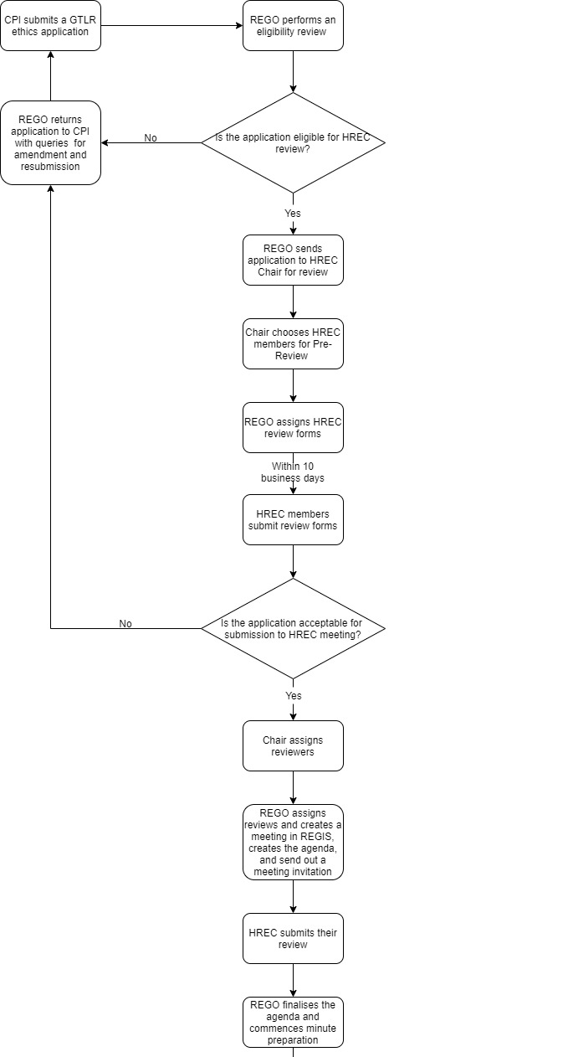

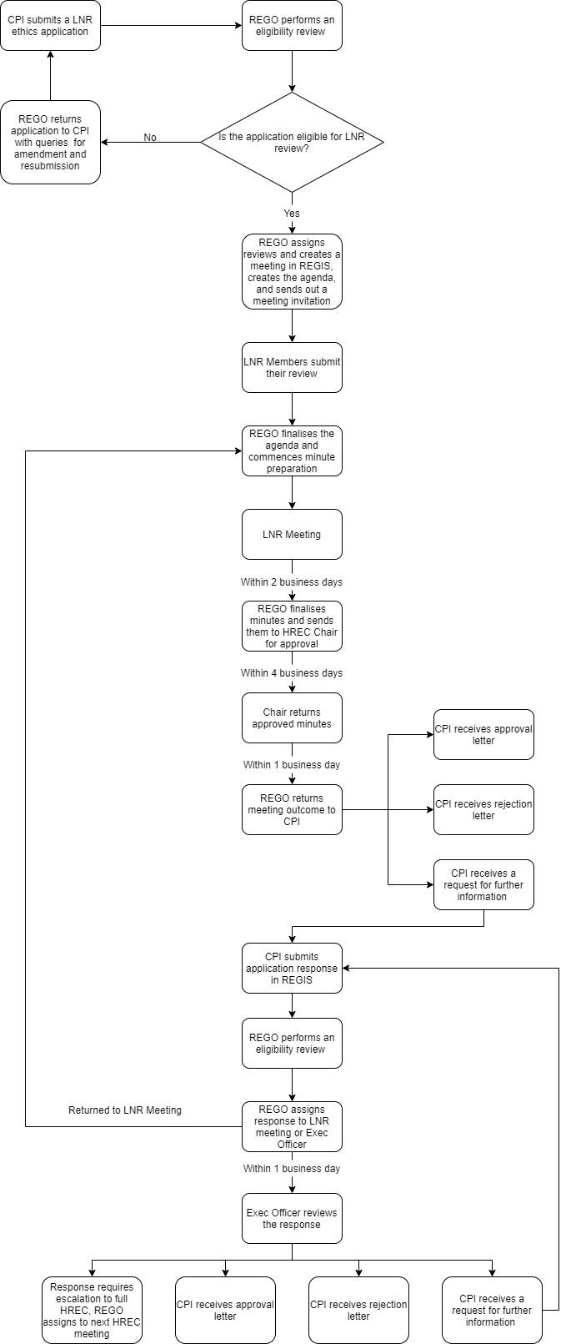
Low/Negligible Risk Applications

  - Processing Amendments
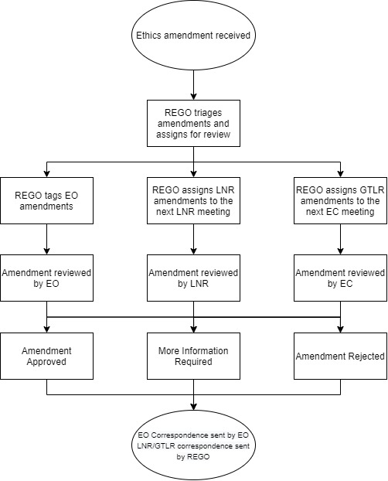

  - Processing Milestones
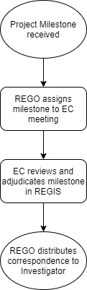

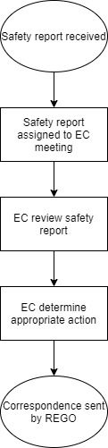
  - Processing Safety Reports

- PROCEDURES
  - Pre-Approval Activities
Pre-approval ethics review is divided into three main tasks:
- Eligibility review (see 001-WI-01 Eligibility Review),
- Meeting and HREC management (see 001-WI-02 Management of HREC Meetings),
- Investigator correspondence (see 001-WI-03 Distribution of HREC Correspondence).
    - Eligibility Review
Eligibility review is performed on all received ethics applications. It is designed to ensure that the applications meet the minimum requirements of the HREC and the Research Office (where applicable) for approval.
Eligibility review is to be conducted by REGO staff in accordance with 001-WI-01 Eligibility Review work instruction and the HREC and RGO Document Requirements sheet. Please review those documents to complete an eligibility review.
    - Meetings and HREC Management
Ethics applications and their responses must be reviewed by the HREC or their delegated party (LNR, EC, or EO) at an appropriately established meeting.
Meeting set-up, agenda creation, and minute taking are detailed in 001-WI-02 Management of HREC Meetings. Please review this work instruction to understand and undertake the processes associated with this task.
    - Distribution of Investigator Correspondence
The final key process in managing the approval of an ethics application is the distribution of correspondence. The ethics correspondence encompasses approvals, approvals with conditions, requests for further information or rejections.
Approvals are issued when the research in its entirety has been accepted by the HREC.
Approvals with conditions are issued when the HREC is happy to approve the research provided a condition is met. These will usually be created when the approval of an additional governing body or ethics committee is required. E.g., a research application has been approved provided it seek approval from the Aboriginal Health and Medical Research Council Ethics Committee prior to commencing. This should not be issued where changes to the application or study documents need to be made.
Requests for further information are divided into “decision pending further information” and “approved pending further information.” Decision pending emails should be sent where the Investigator is required to update the Human Research Ethics Application (HREA) or their study documents. Approved pending emails should only be sent where clarification is required. This email will only generate a More Information Required form where Investigators are able to enter free text.
Rejections are sent to Investigators where the HREC feels that the research is not approvable and cannot be approved with further amendment.
These outcomes will be provided in meeting minutes (for full HREC or LNR meetings), in Regis (for EC outcomes), or will be disseminated by the EO where they have performed the review.
  - Post Approval Activities
Post approval activities involve the management of:
- Ethics amendments,
- Project milestones,
- Safety reporting.
    - Greater Than Low Risk Ethics Amendments
GTLR amendments, excluding EO amendments, are reviewed by the EC. These amendments are assigned to a virtual meeting weekly and adjudicated in REGIS by the HREC Chair (or delegate). The processing of these amendments is described in 001-WI-04 Post Approval Ethics Management.
    - Executive Officer Amendments
The EO (or delegate) can review the following amendments for both GTLR and LNR projects:
- Change in CPI/PI,
- Addition of a New Site,
- Extensions of HREC approval.
These amendments are tagged for EO review as described in 001-WI-04 Post Approval Ethics Management. Where the EO (or delegate) has concerns about an amendment, they will escalate to the HREC Chair.
    - Project Milestones
Investigators are required to submit progress reports in REGIS for HREC review. Progress reports are to be submitted annually from the anniversary of approval. A final report must also be submitted when a study is completed, closed (post-analysis), abandoned or terminated.
REGOs will assign progress reports to the EC for review. Processing project milestones is described in 001-WI-04 Post Approval Ethics Management.
    - Safety Reporting
Sponsors are required to submit the following reports in REGIS for SESLHD HREC review.
- Significant Safety Issues
- Urgent safety measures
- Serious breaches of GCP
Each event is to be assigned to the EC for review and adjudication as described in 001-WI-04 Post Approval Ethics Management.
- ASSOCIATED DOCUMENTS
001-AD-01 Reviewing Ethics Risk Pathways
001-AD-02 HREC and RGO Document Requirements
001-AD-03 Eligibility Checklist
001-AD-04 SESLHD LNR Meeting Agenda Template
001-AD-05 SESLHD HREC Meeting Agenda Template

- REFERENCES
- Human Research Ethics Committees - Quality Improvement & Ethical Review: A Practice Guide for NSW (GL2007_020)
- Operations Manual: Human Research Ethics Committee Executive Officers (GL2010_014)
- ICH E6 Good Clinical Practice
- NHMRC National Statement on Ethical Conduct in Human Research
- NHMRC Safety Monitoring and reporting in clinical trials involving therapeutic goods
- Australian Code for the Responsible Conduct of Research
- Operations Manual: Human Research Ethics Committees (GL2010_013)
- Research - Ethical & Scientific Review of Human Research in NSW Public Health Organisations (PD2010_055)
- Human Research Ethics Committees: Standard Operating Procedures for NSW Public Health Organisations
- South Eastern Sydney Local Health District Human Research Ethics Committee Standard Operating Procedure
- South Eastern Sydney Local Health District Human Research Ethics Committee
- Terms of Reference: Human Research Ethics Committee
- The Privacy Act 1988 (Cth)
- Health Records & Information Privacy Act 2002 (NSW)
- Privacy & Personal Information Protection Act 1998 (NSW)
- REGIS definitions and Investigator guidelines
- RELATED SOPs
- 001-WI-01 Eligibility Review
- 001-WI-02 Management of HREC Meetings
- 001-WI-03 Distribution of HREC Correspondence
- 001-WI-04 Post Approval Ethics Management
- REVISION HISTORY
Version no. | Replaces | Description of change / reason
1.0 | N/A | - Document creation
- APPROVALS
Author | Name: | Olivia Szeto
 | Title: | Research Ethics and Governance Manager
 | Signature: |  | Date:
Reviewer | Name: | Marie Le Bechennec
 | Title: | Research Business Manager
 | Signature: |  | Date:
Head of SESLHD-RO | Name: | Associate Professor Christopher White
 | Title: | Director of Research
 | Signature: |  | Date:

