 | 
Sydney Hospital/Sydney Eye Hospital  8 Macquarie Street,  Sydney NSW 2000 | 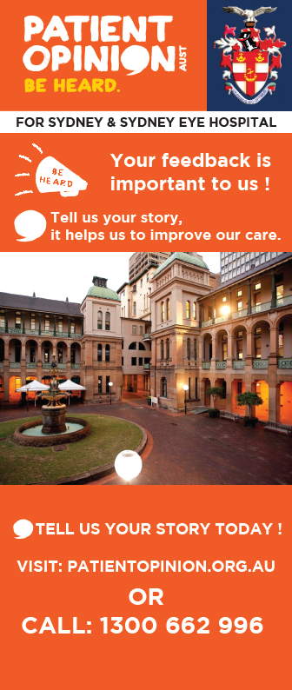
Registered Nurse Transition to Professional Practice – 2021
Perioperative Stream
Come and experience nursing in the heart of the vibrant city of Sydney!
Be part of a dynamic, dedicated, caring, compassionate and person-centred workforce
where nursing first began over 200 years ago.
We are committed to ensuring our 1st Year Transitioning to Practice Registered Nurses are supported and nurtured throughout their transition program to ensure a smooth and enjoyable start to their career in Perioperative Nursing.
Sydney Hospital /Sydney Eye Hospital (SSEH) is located on the site of Australia’s first Hospital.
Sydney Hospital provides general and specialist health care to the public and community including 24 hour emergency care services, general medicine including a close observation unit, peri-operative services, day surgery, specialist hand surgery and ear, nose and throat surgery. Sydney Hospital’s dedicated Hand Unit is a centre of excellence and tertiary referral centre for hand trauma, abnormalities and diseases of the hand.
Sydney Eye Hospital is a centre of excellence and quaternary referral centre for eye health conditions. It performs a vast amount of public eye surgery and provides emergency eye care, ophthalmic health services for inpatient/ outpatient and community outreach programs.
The Transition to Professional Practice Perioperative Stream provides you with an opportunity to undertake two rotations during the 12 month program in the following departments:
- Anaesthetics
- Post Anaesthetic Care Unit (PACU)
- Scrub/Scout
- Day Procedure Unit (DPU)
Commencement date
February 2021
Transition Framework
Our Transition to Professional Practice Framework incorporates the four core transition principles of induction, person-centered work culture, learning and development, and support.
This Perioperative Program is designed to develop and enhance your skills and knowledge as a first year Transitioning Registered Nurse to implement safe, quality patient care within the Perioperative environment. This includes the care of the patient as they journey through the day procedure unit, preoperative, anaesthetics and intraoperative phases and the post anaesthetic care unit. The primary focus of the program is to develop your understanding of the key elements and principles of Perioperative Nursing within a supported clinical learning environment.

We take great pride in enabling transitioning nurses to develop as competent, responsible and accountable Registered Nurses.
Our Transition to Professional Practice Framework is committed to a person centered and facilitated learning approach whereby you as the transitioning nurse continue to be self-determining and responsible for your learning and professional development.
By selecting the Sydney Hospital/Sydney Eye Hospital Perioperative Stream, our Transition to Professional Practice Framework offers the following:-
- Nursing experience in a major teaching hospital in the heart of Sydney
- Five day corporate and nursing orientation program
- Two rotations from four clinical areas within the perioperative stream over a 12 month period
- Ongoing support, guidance and facilitation from preceptors and other clinical resource staff including clinical nurse educators, nurse educator, clinical nurse consultants and a Nurse Manager who is responsible for the implementation and management of the Transition to Professional Practice Framework and its underpinning seven core principles
- A regular program of first year transitioning nurse tailored education sessions, including access to the Hospital wide in-service program, and closed group Clinical Supervision to support Reflective Practice.
- Nursing employment following completion of the program based on position availability and successful application
- NSW Health State-wide uniforms
- Annual leave
- Individualised career pathway planning and development
- Certificate of Achievement on completion of Transition to Professional Practice Perioperative Stream Program
At Sydney Hospital/Sydney Eye Hospital we receive excellent feedback about our Transition to Professional Practice Program from our first year Transitioning to Profession Practice Registered Nurses and we pride ourselves on the retention of 1st year transitioning nurses on staff following completion of their 12 month program.
Accommodation
There is no on-site accommodation at the hospital.
Transport
View Transport Infoline - https://transportnsw.info/
Located in the heart of Australia's most exciting and multicultural city, situated in picturesque grounds, the historical Sydney Hospital/Sydney Eye Hospital is just a 10 minute stroll from the magnificent Sydney Harbour and adjacent to the best shopping, food and entertainment facilities imaginable.
All of this and more is easily accessible with a 24-hour public transport network. The hospitals are close to Town Hall, St James, Wynyard and Martin Place train stations. Buses operate continuously from Sydney's Central Business District. Ferries arrive at Circular Quay, which is just a ten minute walk away.
Subsidised on-site parking facilities are available for your convenience.
Information and contact
If you require further information about what we offer or would like to arrange a visit to the hospital, please email or contact the Transition to Professional Practice Manager:
Lynette Higgs: Telephone: (61) (2) 9382 7412 or (61) (2) 9382 7111 Pager 22107
More information about Sydney Hospital/ Sydney Eye Hospital.
back to Graduates

