A Practical Resource Guide
for Patients/carers & families about
Sydney Hospital & Sydney Eye Hospital

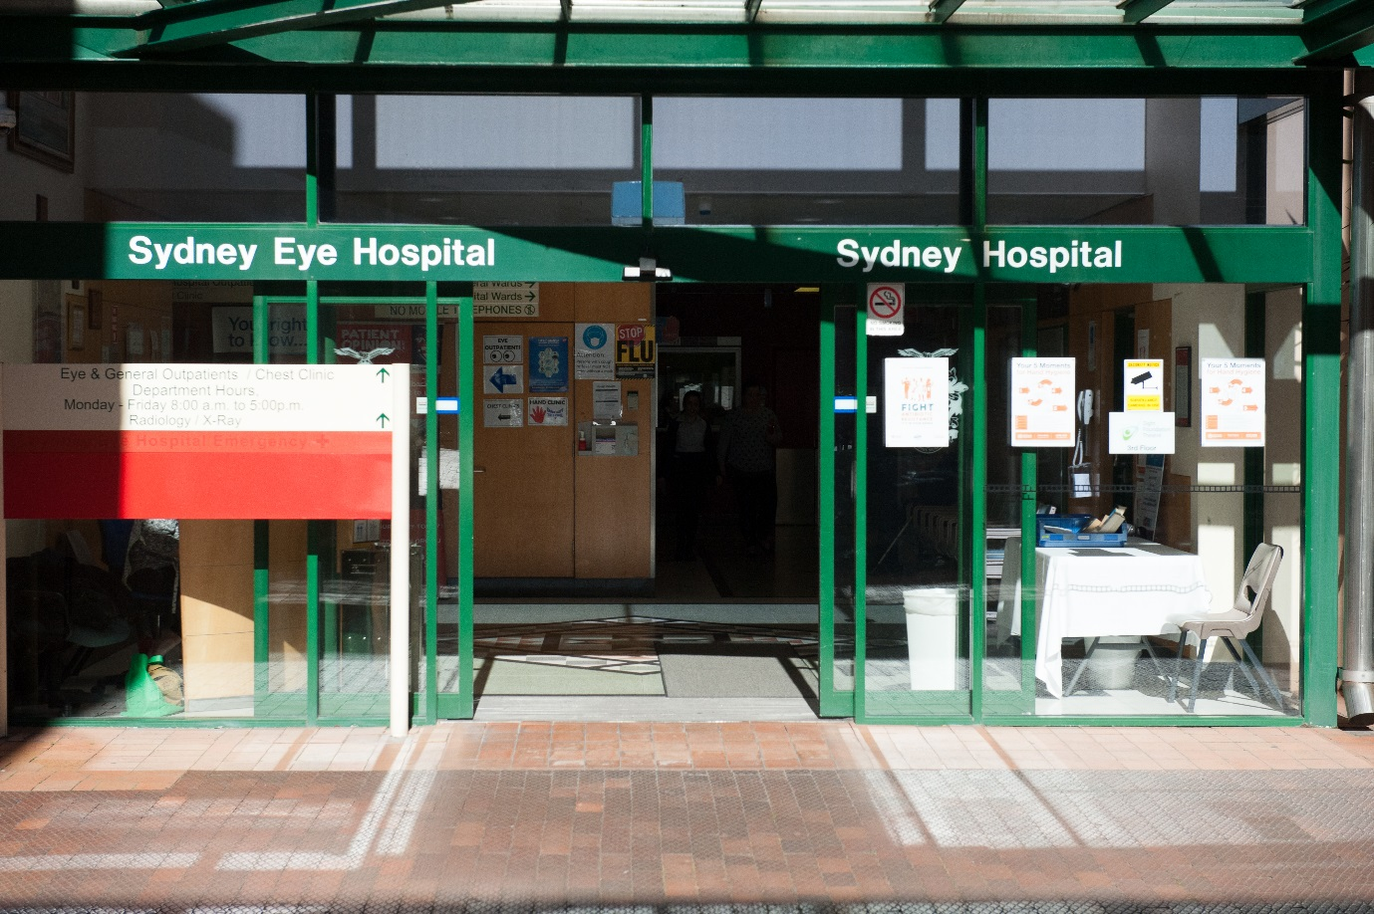
Produced by South Eastern Sydney Local Health District

June 2019
Contents
1 Welcome 3
2 Need an Interpreter? 3
3 Need help while in hospital? 3
4 Visiting Hours 3
5 Checklist - What to Bring? 4
6 Where is Sydney and Sydney Eye Hospital? 5
7 How will you be getting here? 6
8 Other Services 8
8.1 Televisions 8
8.2 Telephones 8
8.3 Accommodation and Isolated Patient Travel and Accommodation Assistance Scheme (IPTAAS) 9
8.4 Accommodation Options 9
8.5 Amenities near the Hospital 11
8.6 General Medical Practices 12
8.7 Chemist/ Pharmacy 13
9 Feedback 14

Welcome
We understand spending time in hospital may be challenging. We hope this information will help make your stay as comfortable as possible.
Sydney Hospital & Sydney Eye Hospital (SSEH) is part of the South Eastern Sydney Local Health District. SSEH provides speciality services in Eye and Hand problems, but also has a General Medicine ward and a 24 hour Emergency Department.
During your stay you will be in contact with a range of hospital staff, which may include medical, nursing, allied health, volunteers, administrative and support staff. All staff are here to help you during your time in hospital.

Need an Interpreter?
Professional interpreters are available if you need help understanding or speaking English, or if you are deaf. They are free and confidential.
Ask staff, it is free and 24 hours, 7 days.

Need help while in hospital?
Ask to speak to a social worker or Nursing staff if you or carer need help for someone or accessing services.

Visiting Hours
Family, friends and carers are welcome to visit you in hospital. Visiting hours in most wards are 10.00am and 8.00pm. Check with the nursing staff on the ward.

Checklist - What to Bring?
Please make sure you bring:
- Identification
- Medicare/medical insurance and/ or pension/concession cards
- Referral letters
- Extra clothing in case you need to stay
- Toiletries in case you need to stay
- Glasses, dentures and other personal aids (e.g. walking stick)
- Contact numbers for family/NOK
- Phone charger
- Wallet/Small amount of Money
- Medications ,Home CPAP (Continuous Positive Airway Pressure machine), scans or X-rays

Notes
________________________________________________________________________________________________________________________________________________________________________________________________________________________________________________________________________________________________________________________________________________________________________________________________________________

Where is Sydney and Sydney Eye Hospital?

Sydney Hospital & Sydney Eye Hospital is located at:
8 Macquarie Street, Sydney NSW 2000 Australia
GPO Box 1614, Sydney NSW 2001 Australia
Telephone: 61 2 9382 7111
Facsimile: 61 2 9382 7320

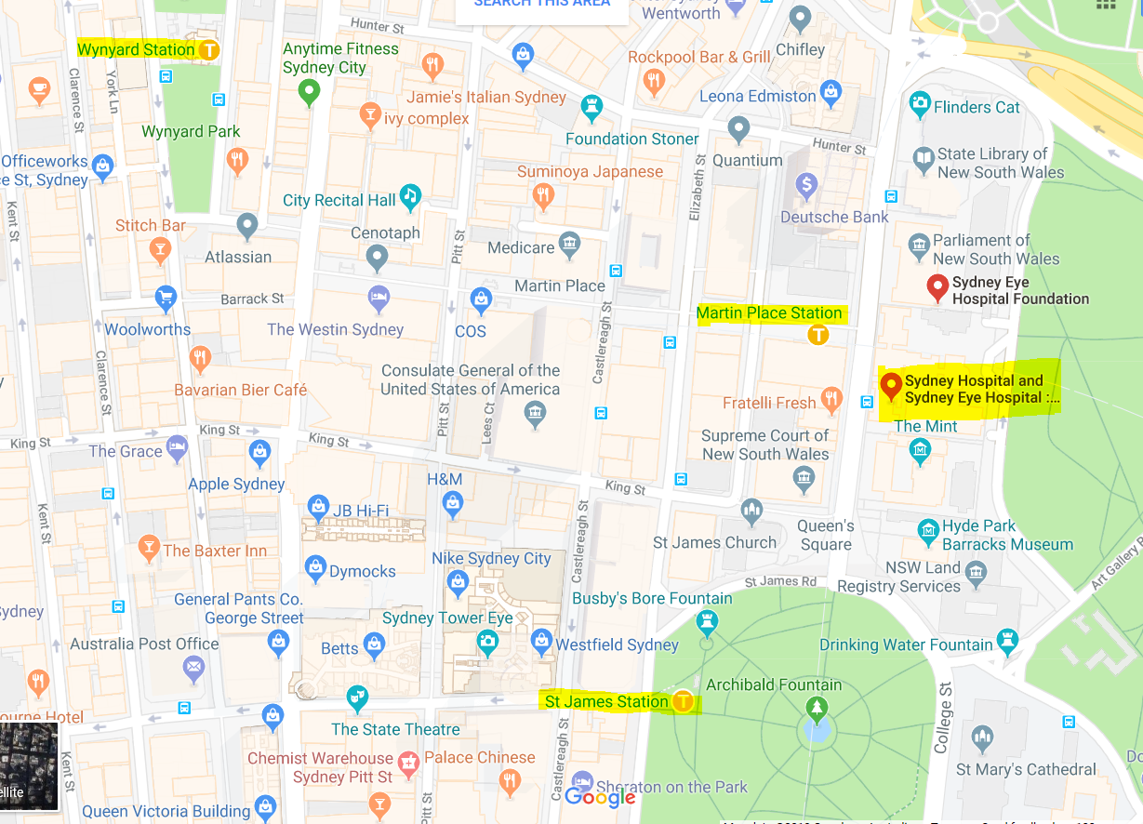

How will you be getting here?
Train:
If you are coming on a Countrylink train, you will need to get off at Central train station.
Proceed to platform 25 at Central station. Catch the train heading in the direction of Bondi Junction. Get off at Martin Place train station.
From Martin Place train station, exit towards Macquarie St.
Sydney/Sydney Eye Hospital is the building across from the station with the Boar Statue (Next to Parliament House).
Please note- The Sydney public transport network uses the’ Opal Card’ system, so you will need to order this/purchase one in order to commute around Sydney on Public Transport. Adult & Child/Youth opal cards can be purchased at most newsagents, post offices, convenience stores and supermarkets. Concession or Gold Senior/Pensioner opal cards must be ordered online or by calling 13 OPAL (13 6725).
Useful Public Transport Websites:
www.opal.com.au
www.sydneytrains.nsw.gov.au
www.countrylink.nsw.gov.au
From the Airport:
You can get a taxi or train to Sydney/Sydney Eye Hospital. The train is located in the Domestic Terminal. You will need to catch a train to Central station. Proceed to platform 25 at Central station. Catch the train heading in the direction of Bondi Junction. Get off at Martin Place train station.

Taxi/Uber:
Ask to be dropped off at Sydney/Sydney Eye Hospital, on Hospital Rd.
Taxi Services:
13 CABS: 13 22 27. Wheelchair accessible taxi - Phone: (02) 8332 0200
Premier Cabs: 13 10 17. Maxi taxi (wheelchair & baby capsule accessible) - Phone: (02) 8868 4555
St George Cabs: 13 21 66. Maxi taxi (wheelchair & baby capsule accessible)
Driving:
There is a private parking station under Sydney Hospital & Sydney Eye Hospital, accessed from Hospital Road. There is also a limited number of metered parking spaces available on Hospital Road. Check with ward staff to get flyer for discounted parking with Metro Parking.
Metro Parking (02) 9789 1689
Please check website to obtain current parking rates.
http://www.metroparking.com.au/commercial-parking/new-south-wales-c/sydney-eye-hospital
Concession rates
Patient and carers eligible to obtain concession rates when parked in public hospital car parks include:
- Holders of eligible government cards
- Patients and their carers who attend the hospital/facility on an ongoing basis for treatment.
http://www.parking.health.nsw.gov.au/show.html?language=en&name=Sydney Hospital and Sydney Eye Hospital

Map of the Hospital Grounds
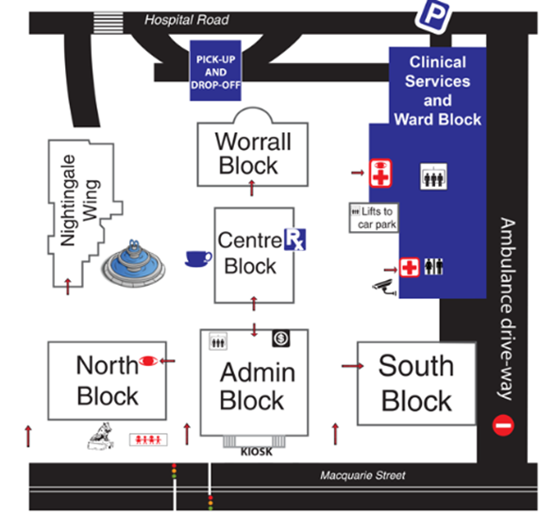

Other Services

Televisions
Each bed has access to a television. You will need to pay to view TV channels.

Telephones
There is a telephone by each bed. Please see the nursing staff for the number.
You can use your mobile telephone, please be courteous and respectful of others. Please do not take video or photos of others without getting consent first.

Accommodation and Isolated Patient Travel and Accommodation Assistance Scheme (IPTAAS)
The government assists residents of NSW with travel and accommodation costs if you live 100km or further away from Sydney (one way) and have been referred by your doctor for Sydney treatment under the Isolated Patient Travel and Accommodation Assistance Scheme (IPTAAS). Please note – IPTAAS will not be a possibility if you are referred but under another insurance scheme (i.e. WorkCover; Motor Accident Authority).

ITPAAS application forms and contact details can be found at: http://www.enable.health.nsw.gov.au/iptaas

Are you a carer or medical escort?
If you are a carer or medical escort travelling with the patient you may also be entitled to assistance through IPTAAS.

For further information contact: 1800 IPTAAS (1800 478 227)

Accommodation Options

PLEASE NOTE:
Prices are subject to change depending on time of booking. The prices and information in this document were updated in January 2018. The hospital takes no responsibility for the services provided by these hotels. Please confirm costs before you book a room.

Elizabeth Hunter Lodge
Cnr Carrington Rd & 125 Birrell Street Waverley NSW 2024.
Situated in the grounds of the War Memorial Hospital
Telephone: (02) 9369 0307. Please book in advance before 5pm.
$85 Twin $65 Single (bulk billing please enquire)
Secure Parking
Proximity to hospital: 20 minute-drive, 24 minute-public transport

Hotel Harry
Sydney South 42 Wentworth Ave. Sydney 2000
Telephone: (02) 8262 8844
Average rate $129-185
Proximity to hospital: 6 minute-drive, 16 minute-walk, 11 minute-public transport

Song Hotel Sydney (Formerly Y Hotel Hyde Park)
5 - 11 Wentworth Ave Sydney NSW 2000
Telephone: (02) 9264 2451 Website: http://www.yhotel.com.au
Minimum cost $59 per night / single room with shared bathroom
Family and studio rooms available, approximately $149 per night
One wheelchair accessible room
Proximity to hospital: 5 minute-drive, 14 minute-walk, 11 minute-public transport

Travelodge
165 Phillip Street, Sydney
Telephone: (02) 8224 9400 Website: www.travelodge.com.au
Microwave & kettle in room
Range in price from $120- $250

Proximity to hospital: 3 minute-walk

Macleay Serviced Apartments Hotel
28 Macleay Street Potts Point NSW 2011
Telephone: (02) 9357 7755 Website: www.TheMacleay.com
Average rate for hospital clients $155 per room per night.
Limited secure parking available at a fee.
Proximity to hospital: 10 minute-drive, 22 minute-walk

The Sydney Lodge Motel
44 New South Head Rd Edgecliff NSW 2027
Telephone: (02) 9328 0666
Range in price $120 - $140 per night incl. Continental breakfast
Proximity to hospital: 10 minute-drive, 35 minute-walk

Hyde Park Inn
271 Elizabeth St Sydney NSW 2000
Telephone: (02) 9264 6001 Website: www.hydeparkinn.com.au
Standard room price ranges from $176 – $242 per night (kitchenette)
Larger rooms available
Proximity to hospital: 5 minute-drive, 12 minute-walk

Castlereagh Inn
171 Castlereagh St, Sydney NSW 2000
Telephone: (02) 9284 1000 Website: www.thecastlereagh.com.au
Average price $170
Proximity to hospital: 5 minute-drive, 10 minute walk

Useful Accommodation websites
www.airbnb.com.au
www.wofif.com.au
www.bookings.com.au
www.agoda.com.au
www.trivago.com.au

Amenities near the Hospital
Food and Coffee
Friends of Sydney Hospital (FOSH) have a volunteers stall located in the foyer on the ground floor of the Clinical Services Building where you can purchase snacks, sandwiches and drinks.
Vending machines are located on Level 1 of the Clinical Services Building and outside the Emergency Department.
The Courtyard Café is located on the grounds of Sydney/Sydney Eye Hospital.
Additional cafes are located opposite the hospital along Macquarie Street. Nearby eateries are located in the Martin Place Shopping Circle and the MLC Centre.
Supermarkets
IGA – 29 Martin Place, Sydney (located in the MLC Centre).
Opening hours: 6am-10pm

Coles – 388 George Street, Sydney
Opening hours: 6am-12 midnight

Woolworths (Metro)-Pitt Street Mall, 400 George St, Sydney
Opening Hours: 6am-10pm

Post Office
Australia Post, Parliament of NSW.
6 Macquarie Street, Sydney.
Phone: (02) 9230 2297
Opening Hours: Mon-Fri, 9am-5pm

Post Office
1 Martin Place, Sydney.
Phone: (02) 9244 3711
Opening hours: Mon-Fri, 8.15am-5.30pm. Sat: 10am-12pm

General Medical Practices
Macquarie St Medical Practice
Ground Floor 195 Macquarie St Sydney
Phone: 92380800
Operating Hours: Monday- Friday 8am to 6pm
Bulk Billing is only for pensioners/health care card holders and people under 16 years. http://macquariestreetmedicalpractice.com.au/services/

Sydney CBD Medical Centre
242 Castlereagh St Sydney
Phone: 9268 0133
Operating Hours: Monday- Friday 8am to 6:30pm. Closed Weekends

Bulk Billing

Sydney Premier Medical and Health Centre
309 Pitt St Town Hall
Phone: 8964 8677
Operating Hours: Monday- Friday 8am to 6pm. Closed weekends.
Bulk Billing is only for NSW residents with a Medicare Card.

Hyde Park Medical Centre
Ground Floor, Shop 1, 175 Liverpool St Sydney
Phone: 9283 1234
Operating Hours: Monday- Friday 0800- 1830
Sat 1000- 1700 and Sunday 1000-1400
Bulk billing is only available if you have an appointment Monday-Friday 0800- 1730.
Please note: No bulk billing on weekends.

Chemist/ Pharmacy
Macquarie Street Pharmacy
195 Macquarie St, Sydney.
Phone: (02) 9221 1542
Opening Hours: Mon – Fri, 7.30am-6.30pm. Sat: 10.30am-2.30pm.

Bland Centre Pharmacy
229 Macquarie Street, Sydney.
Phone: (02) 9231 2165
Opening Hours: Mon-Fri, 7.30am-6pm.

Colonial Centre Pharmacy- Sydney CBD
Shop 12, 52 Martin Place, Sydney.
Phone: (02) 9232 7912
Opening Hours: Mon-Fri, 7.30am-6pm

Feedback
At Sydney Hospital & Sydney Eye Hospital we aim to provide you with the best care possible. Feedback helps us understand what is working well, and where we can improve.
You can give us feedback through the below options:
- discuss with staff on the ward/department

- Patient Opinion at www.patientopinon.org.au or phone 1300662996

- The Patient Safety and Clinical Improvement Manager
SESLHD-SSEHConsumerFeedback@health.nsw.gov.au
Or phone number 02 9382 7323.
Or write a letter
Sydney Hospital and Sydney Eye Hospital
GPO Box 1614, Sydney, NSW, 2001

All feedback will be treated with respect and confidentially. Your valuable feedback will help us improve how we deliver care.

