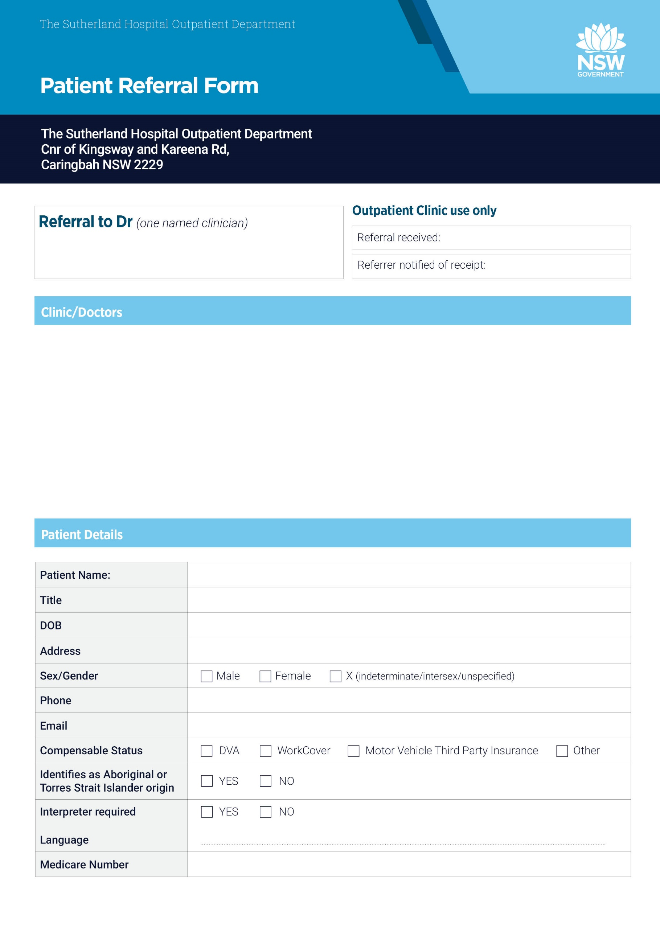
PHONE:
FAX:
EMAIL:

Respiratory and Sleep  Dr Clarissa Susanto  Dr Teresa Louie  Dr Chin Goh  Dr Vicki Chang  Dr Con Archis  Dr Greg Katsoulotos  Dr Johnathan Man | Endocrinology  Dr Malgorzata Brzozowska  Dr Michael Bennett  Dr Ganesh Chockalingam  Dr Michael Reyes | Neurology  Dr Ik Lin Tan  Dr Manisha Narasimhan  Dr Benjamin Nham  Dr Rajiv Wijesinghe  Dr Sully Fuentes-Patarroyo  Dr Derick Soh | Gynaecology PH-9540 7240  Dr Amani Harris  Dr Dean Conrad  Dr John Breen  Dr Chandra Krishnan
Infectious Diseases:  Dr Robert Stevens  Dr Ben Knippenberg  Dr Roselle Robosa | Rehabilitation  Dr Lucy Ramon  Dr Eunice Lin | Paediatrics PH- 9540 7384  Dr Alys Swindlehurst  Dr Henry Gilbert  Dr James Tong  Dr Elizabeth Berger

